CATHERINE SMEREENA DOMMATY

  catherinesmereena.dommaty@gmail.com

**Introduction**

This assignment focuses on examining hospital bed capacity and utilisation across various hospitals and bed categories. The primary goal is to design a database schema, implement it using MySQL, and write SQL queries that address important business questions related to bed availability, hospital usage, and specific bed types, such as ICU and SICU beds. The emphasis will be on structuring the data for clarity and efficiency, extracting valuable insights from the hospital data, and presenting the findings in a clear manner.

**Goals and Expectations**

- Develop an efficient Star Schema for analysing hospital bed capacity.

- Execute SQL queries to answer essential business questions about bed allocation, licensed beds, staffed beds, and census beds.

- Analyse the utilisation of ICU and SICU beds.

- Provide recommendations based on the analysis, detailing how hospitals can effectively manage their resources.

**Dataset Description**

The dataset comprises hospital data that includes information about total licensed beds, staffed beds, and various bed categories. It consists of three main tables:

1. Hospital Table (Dimension Table 1): This table contains specific information about hospitals, such as the IMS organisation ID, hospital name, and total bed counts.

2. Bed Category Table (Dimension Table 2): This table provides details about different bed types, including bed ID, code, and descriptions.

3. Bed Capacity Fact Table: This table holds factual data regarding bed capacity, including licensed, census, and staffed beds for each bed category.

**Tools and Languages**

- ERDPlus: Used for designing the Entity-Relationship Diagram (ERD).

- MySQL Workbench: Utilised for creating the database, executing SQL queries, and conducting analysis.

- SQL: Employed for querying the database and retrieving insights from the data.

**Task 1: Identifying Dimensions in the Hospital Bed Capacity Schema**

In order to effectively analyse hospital bed capacity and utilisation, we need to categorise our data into dimensions and facts. This structured approach allows us to organise the information in a way that facilitates meaningful insights. Below, we outline the dimensions and facts based on the provided schema.

**–Dimension Table 1: Bed_Category**

**1. Dimension 1: `bed_id`**

The `bed_id` is a unique identifier for each category of beds within the hospital. This allows for precise categorization and tracking of different bed types, which is essential for data analysis and reporting.

**2. Dimension 2: `bed_code`**

This attribute represents a code that corresponds to the type of bed, such as ICU (Intensive Care Unit) or SICU (Surgical Intensive Care Unit). The bed code simplifies data management and querying, making it easier to filter results based on specific bed types.

**3. Dimension 3: `bed_description`**

The `bed_description` provides a detailed explanation of each bed category. This information is valuable for understanding the context of the data and can be used in reports to clarify the types of beds available in each category.

**–Dimension Table 2: Hospital**

**1. Dimension 1: `ims_org_id`**

This is a unique identifier assigned to each hospital. It serves as a primary key in the database, ensuring that every hospital can be distinctly recognized. This ID is crucial for linking hospital-specific data across different tables.

**2. Dimension 2: `hospital_name`**

This attribute represents the name of the hospital. It is essential for human readability and reporting, allowing users to easily identify hospitals when analysing data. The hospital name can be used in queries to filter or group data by specific facilities.

**3. Dimension 3: `total_license_beds`**

This dimension indicates the total number of licensed beds available in a hospital. It provides a baseline for understanding the hospital's capacity and is critical for assessing whether a hospital can meet patient demand based on its licensed capacity.

**Task 2:**  **Identifying Facts in the Hospital Bed Capacity Schema**

**Fact Table: Bed_Capacity_Fact**

**1. Fact 1: `license_beds`**

This fact represents the total number of licensed beds allocated to each category within a hospital. It is a key metric for evaluating the hospital's capacity to accept patients and is essential for operational planning.

**2. Fact 2: `staffed_beds`**

The `staffed_beds` fact indicates the total number of beds that are actively staffed and available for patient use. This metric is critical for understanding the hospital's operational readiness and its ability to provide care to patients.

**3. Fact 3: `census_beds`**

This fact reflects the number of beds that are currently occupied or in use at the hospital. It helps assess bed utilisation rates and can inform decisions regarding resource allocation and patient management.

**Task 3:**

Step 1: Starting the Star Schema Development

I began the process by choosing the "Star Schema" option in the ERDPlus tool, naming the diagram "Healthcare_Bed_Capacity." This initial step was crucial as it set the foundation for analysing hospital bed capacity and utilisation. By organising the necessary tables and defining their relationships, I aimed to create a clear and structured representation of the data.

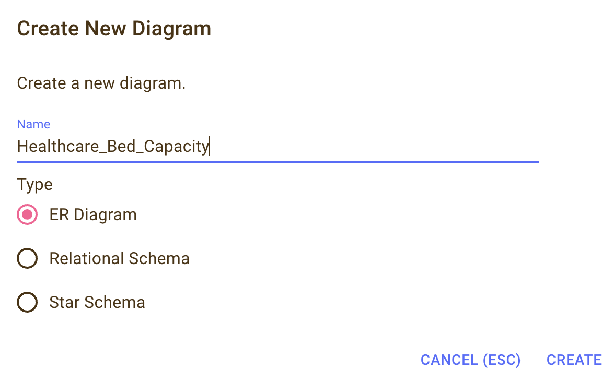

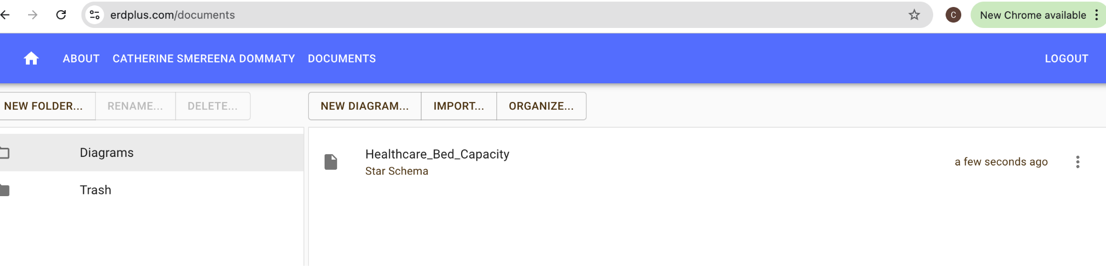

Step 2: Defining the Fact Table

In the next step, I selected the "Fact" option in ERDPlus to establish the Fact Table that would house the quantitative data essential for my analysis. This fact table is designed to capture key metrics related to hospital beds, such as licensed beds, census beds, and staffed beds.

I created a table named bed_capacity_fact to store all relevant numerical data associated with hospital bed capacity.

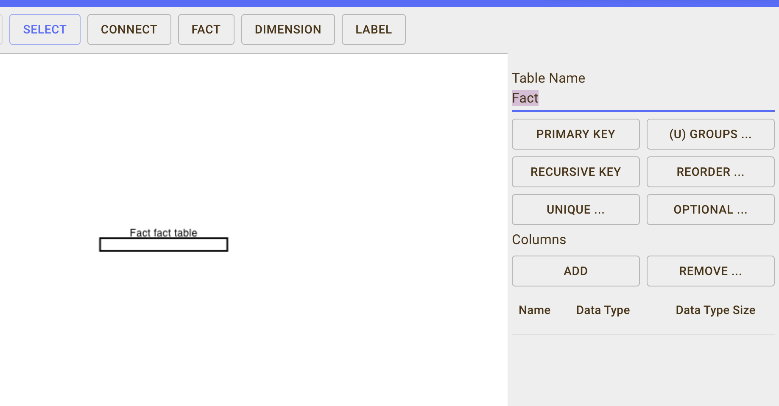

Next step I added Columns according to the table

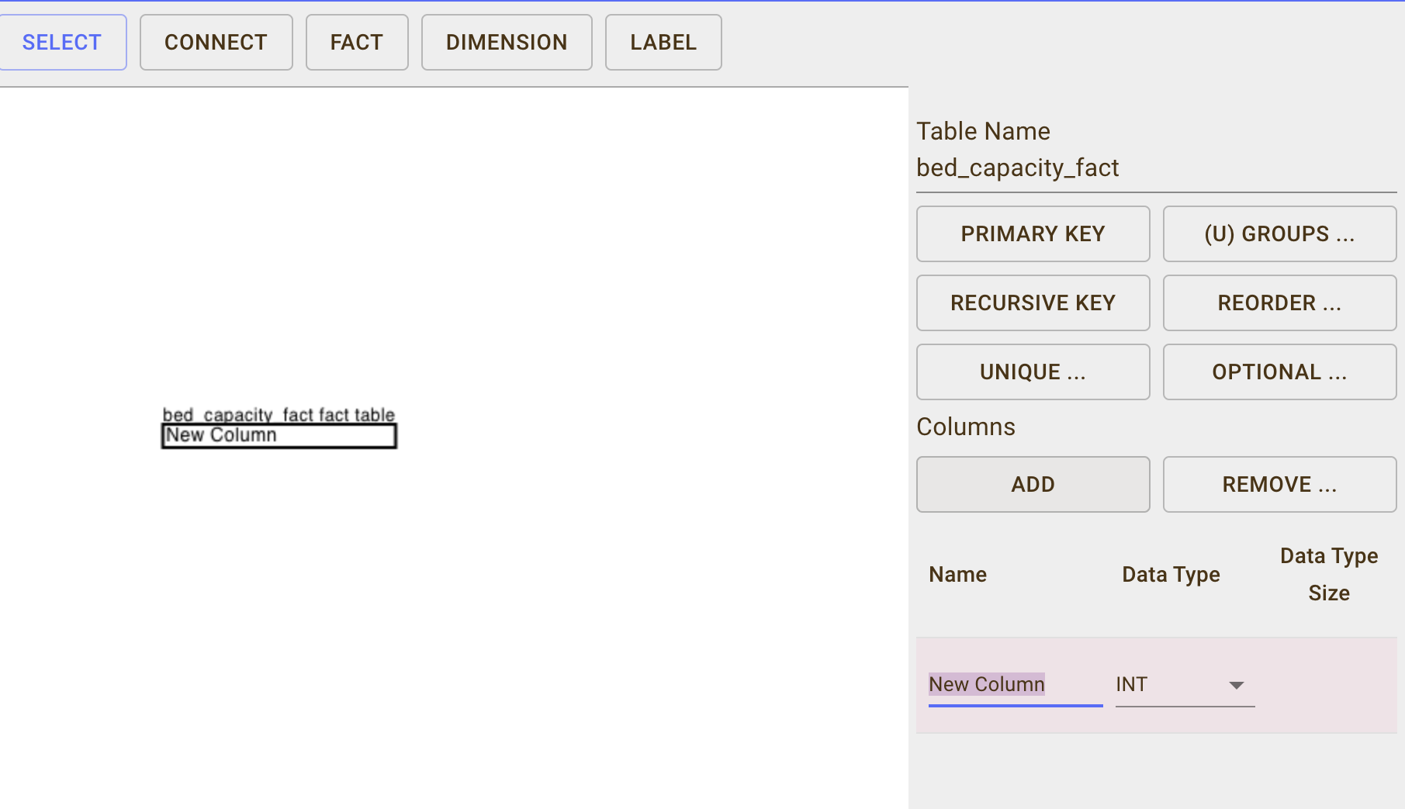

Step3:Next, I renamed the table to bed_capacity_fact to reflect its purpose within the star schema accurately. To ensure it captured all necessary metrics, I added the following columns by selecting the "Add" option in the Columns section:

license_beds (INT): This column tracks the number of licensed beds available in each hospital or healthcare facility, as mandated by regulatory authorities.

census_beds (INT): This column records the total number of census beds in the hospital, representing those available for patient admission.

staffed_beds (INT): This column indicates the count of staffed beds ready for immediate patient care, reflecting the hospital's capacity to manage patient needs with available personnel.

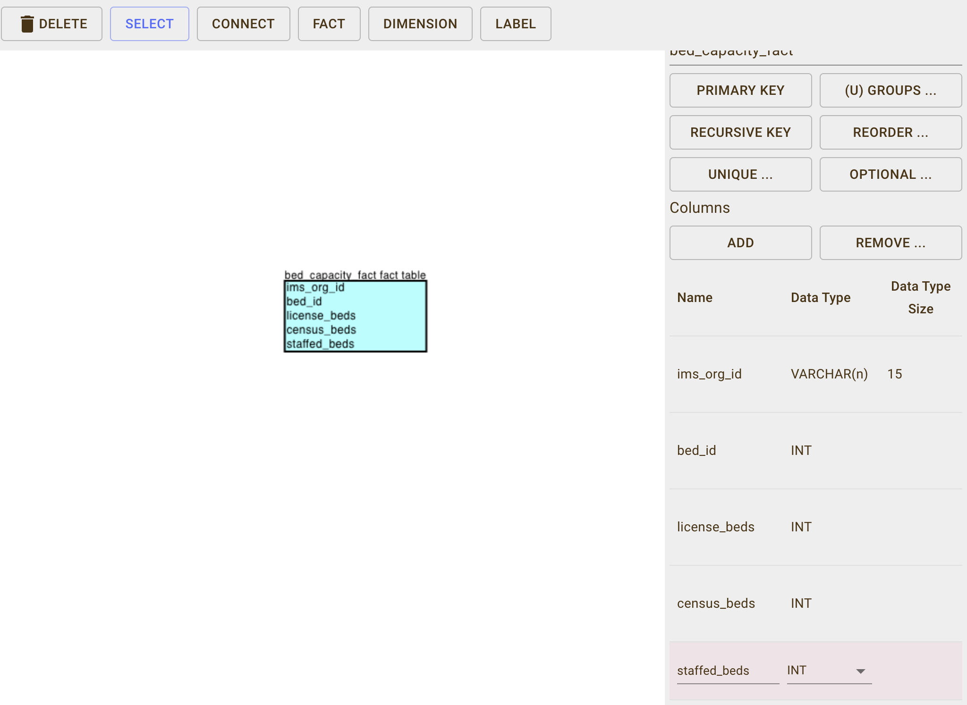

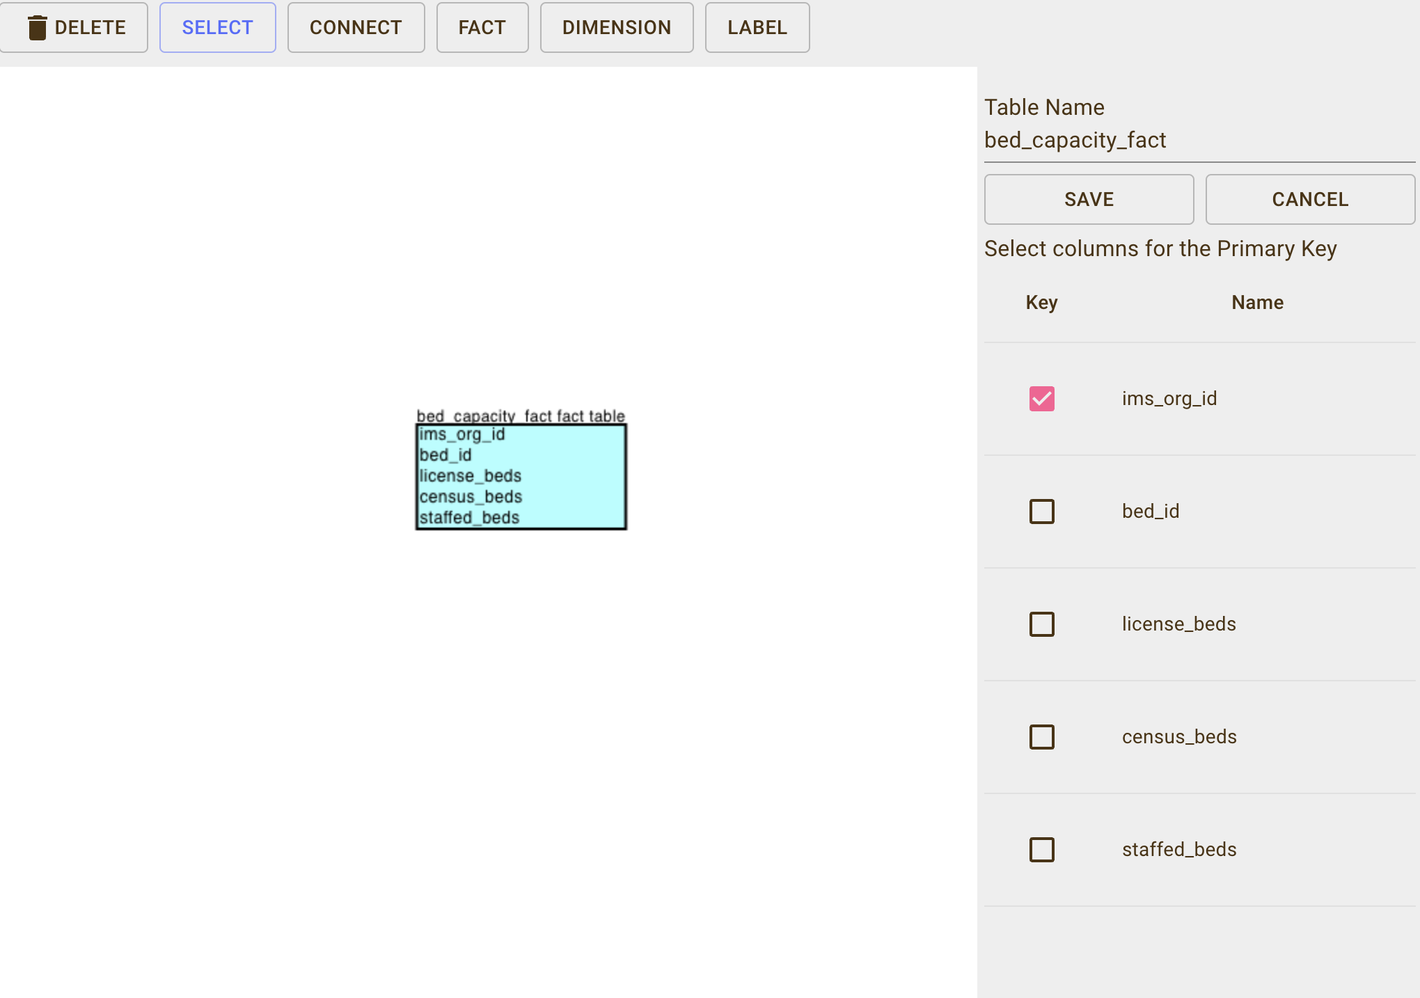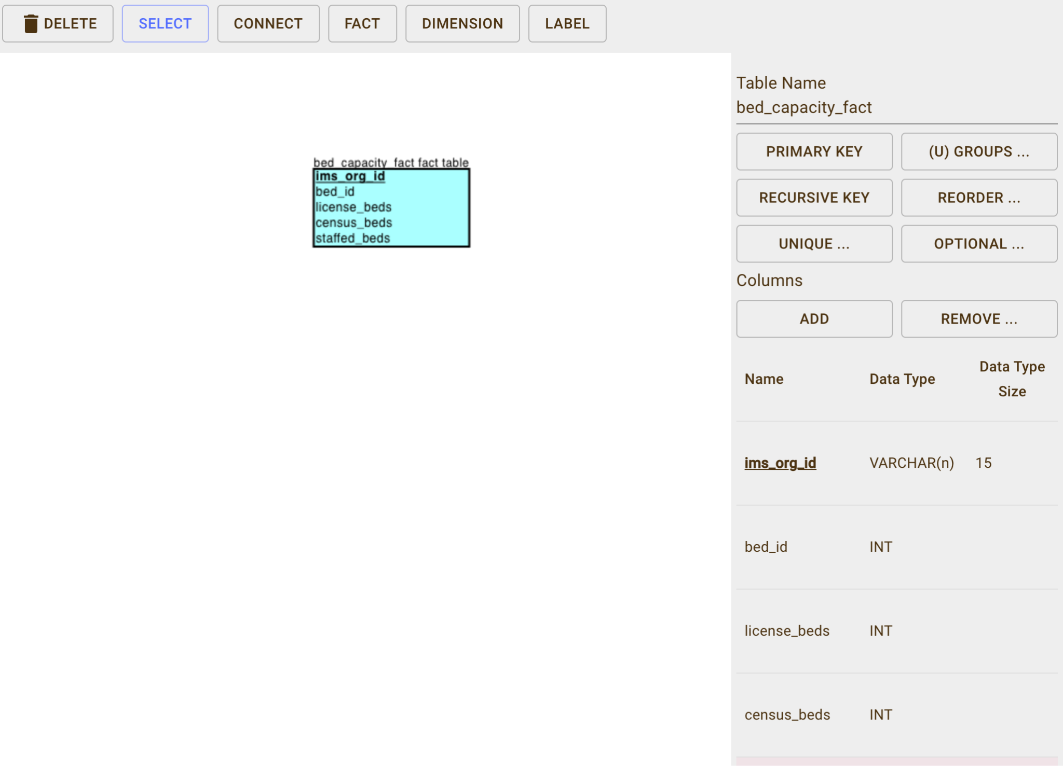

Here’s a summary of the bed_capacity_fact table I created, including these essential columns:

–license_beds

–census_beds

–staffed_beds

**Dimensions:**

Step 1: Establishing the Dimension Table

After successfully setting up the fact table, I moved on to create the dimension table named bed_category. By selecting the "Dimension" option in the ERDPlus tool, I was able to define a table that would store descriptive data related to the various types of hospital beds. This table is essential for providing context and details that will enhance the analysis of bed utilisation and capacity.

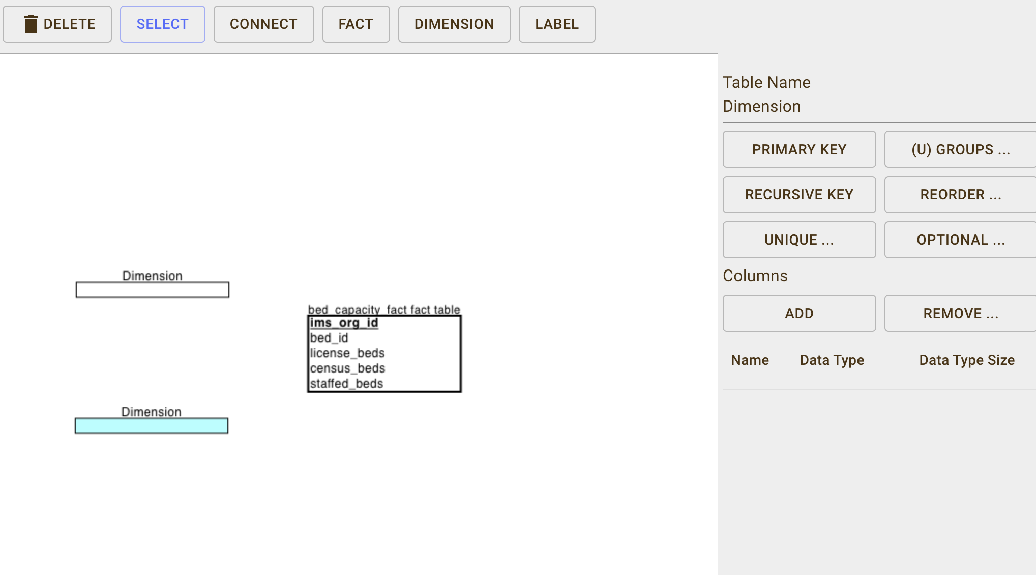

Step 2: Adding Columns to the Dimension Table

Next, I renamed the table to bed_category to accurately reflect its role within the star schema. I then added the following columns by using the "Add" option in the Columns section:

bed_id (INT): This column serves as the unique identifier for each bed category. It will establish a link between the bed_category dimension table and the bed_capacity_fact fact table, allowing for effective data relationships.

bed_code (INT): This column holds a short code that uniquely identifies each type of bed category. This concise reference facilitates quick identification during data analysis.

bed_description (VARCHAR): This column provides a detailed description of each bed category (e.g., ICU, General, Pediatric). This information is crucial for understanding the context and classification of different types of beds.

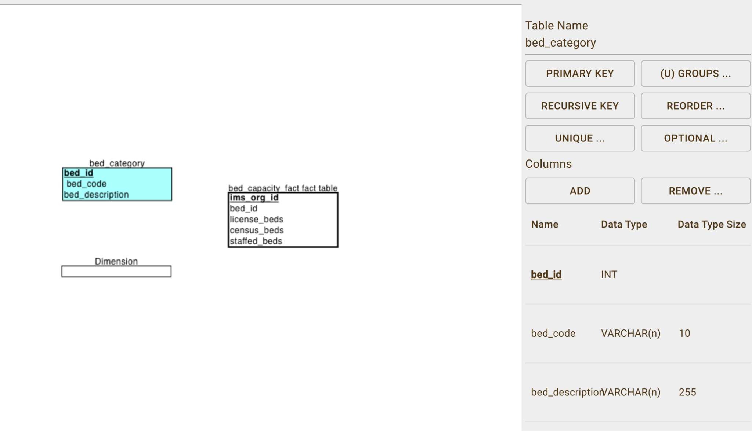

After adding the necessary columns, I selected the "Primary Key" option to designate the unique identifier for the bed_category table. This step is important for ensuring data integrity and establishing clear relationships within the schema.

Assigning bed_id as the Primary Key

In this step, I designated bed_id as the Primary Key for the bed_category table. Choosing bed_id as the primary key guarantees that each bed category is uniquely identifiable within the table. This prevents duplication and ensures a reliable connection between the bed_category dimension table and the bed_capacity_fact fact table.

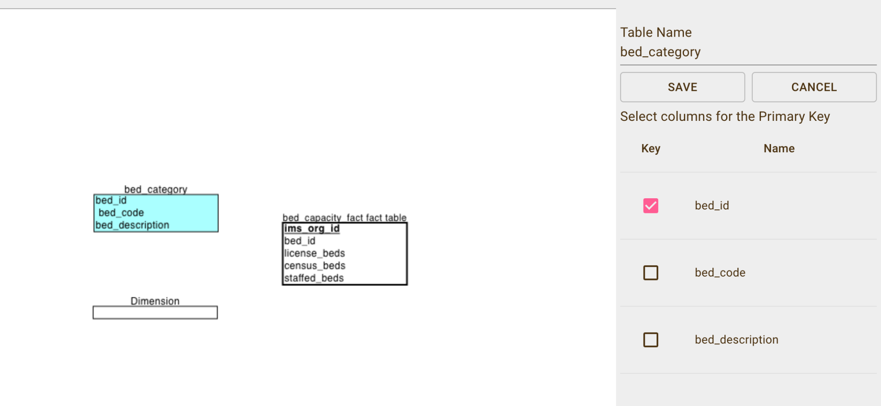

Upon completing the previous steps, the bed_category table consists of the following three columns:

**bed_id:** The primary key and unique identifier for each bed category.

**bed_code:** A concise reference code for each type of bed category.

**bed_description:** A detailed description of each bed category, providing context for analysis.

By creating this bed_category table, I have established a solid foundation for defining the descriptive attributes associated with different bed categories in hospitals. This table will work in conjunction with the fact table to facilitate comprehensive analysis of hospital bed utilisation and capacity.

**Dimension 2:**

I renamed the table to hospital to accurately reflect its purpose within the schema. Using the "Add" option in the Columns section, I included the following key attributes for the hospital table:

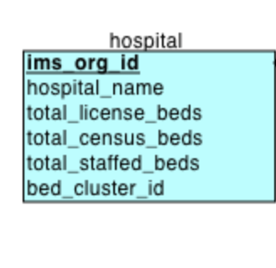

**ims_org_id (INT):** This column acts as a unique identifier for each hospital or healthcare organisation, ensuring that every facility can be distinctly recognized within the system.

**hospital_name (VARCHAR):** This column stores the name of the hospital or healthcare facility, providing clarity and ease of identification for each organisation in the dataset.

**total_license_beds (INT):** This attribute records the total number of licensed beds that the hospital is authorised to operate, as outlined by regulatory guidelines.

**total_staffed_beds (INT):** This column captures the total number of beds that are actively staffed with medical personnel, reflecting the hospital's capacity to provide care.

**bed_cluster_id (INT):** This identifier is used for clustering or grouping beds within a hospital based on specific categories, such as departments or wings.

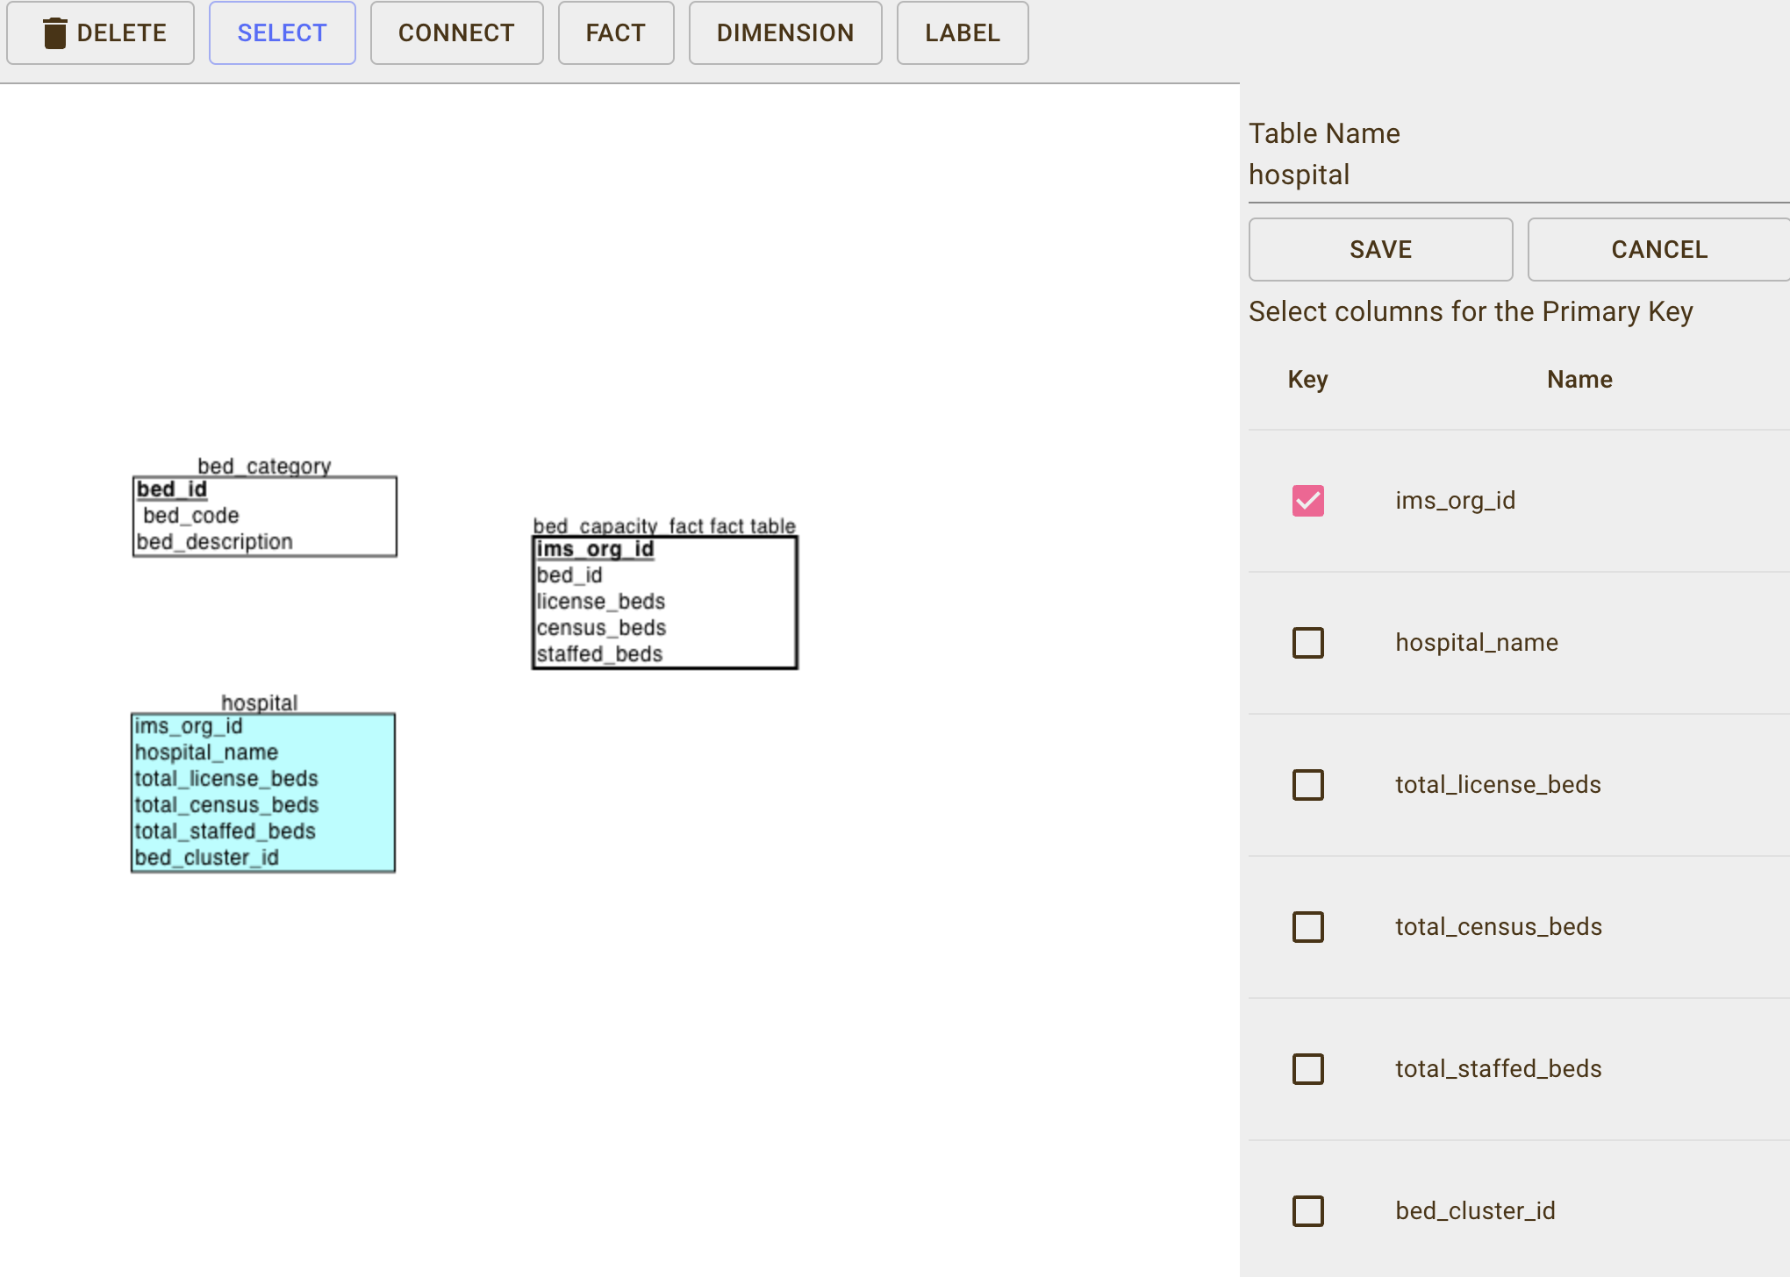

In this step, I selected the "Primary Key" option to establish the primary key for the hospital table. This is crucial as it ensures that every record in the hospital table has a unique identifier, which can be used for joining with other tables in the schema.

I designated ims_org_id as the primary key for the hospital table. This choice is vital because it serves as the unique identifier for each hospital or healthcare organisation, preventing any duplicate entries. By setting ims_org_id as the primary key, I can maintain data integrity while establishing relationships between the hospital dimension table and the bed_capacity_fact fact table.

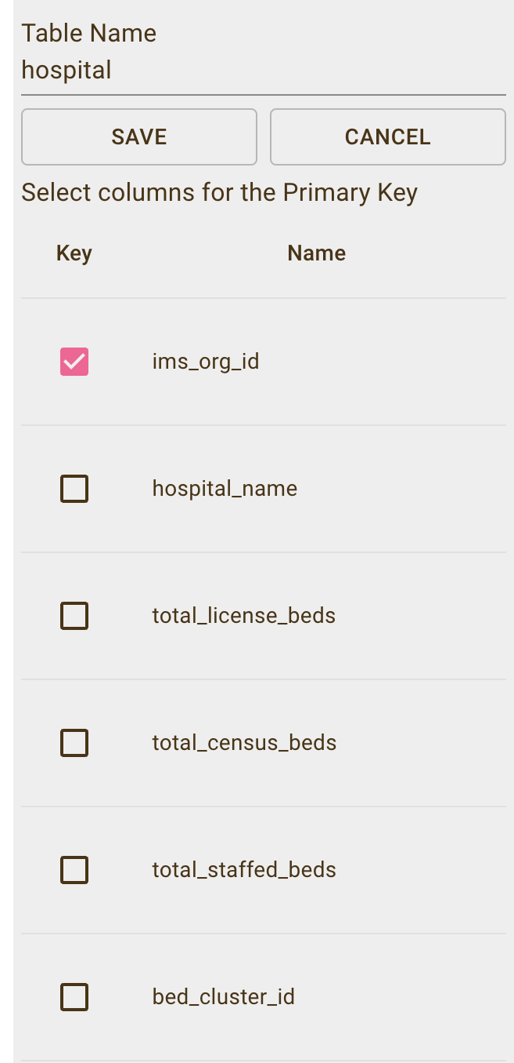

The completed hospital table consists of the following columns:

ims_org_id (Primary Key): Unique identifier for each hospital.

hospital_name: The name of the hospital or healthcare facility.

total_license_beds: The total number of licensed beds available in the hospital.

total_staffed_beds: The total number of staffed beds ready for patient care.

bed_cluster_id: An identifier used for grouping beds within the hospital.

**STAR SCHEMA CREATION FOR HEALTHCARE_BED_CAPACITY**

After defining the dimension and fact tables, I utilised the Connect option in the ERDPlus tool to establish relationships between the tables, which is a crucial step in developing the star schema for the Healthcare_Bed_Capacity database. By linking the dimension tables to the fact table, I ensured data integrity and facilitated effective querying.

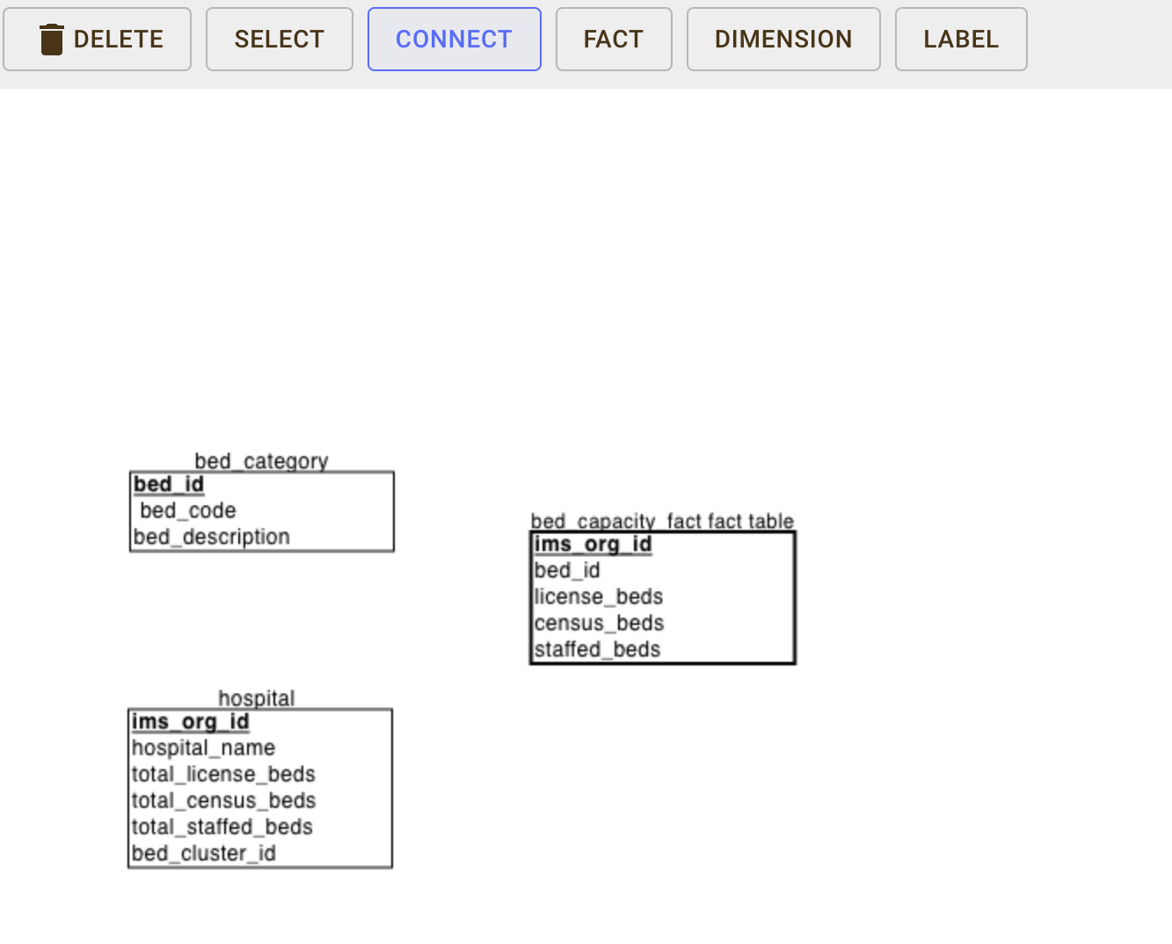

Step 1: Connecting Dimension Tables to the Fact Table

Connecting the Bed Category Table to the Fact Table:

Next, I selected the bed_category table (dimension) and linked it to the bed_capacity_fact table. This connection created a relationship between bed_id in the bed_category table (primary key) and the foreign key bed_id in the bed_capacity_fact table, allowing for accurate categorization of bed data.

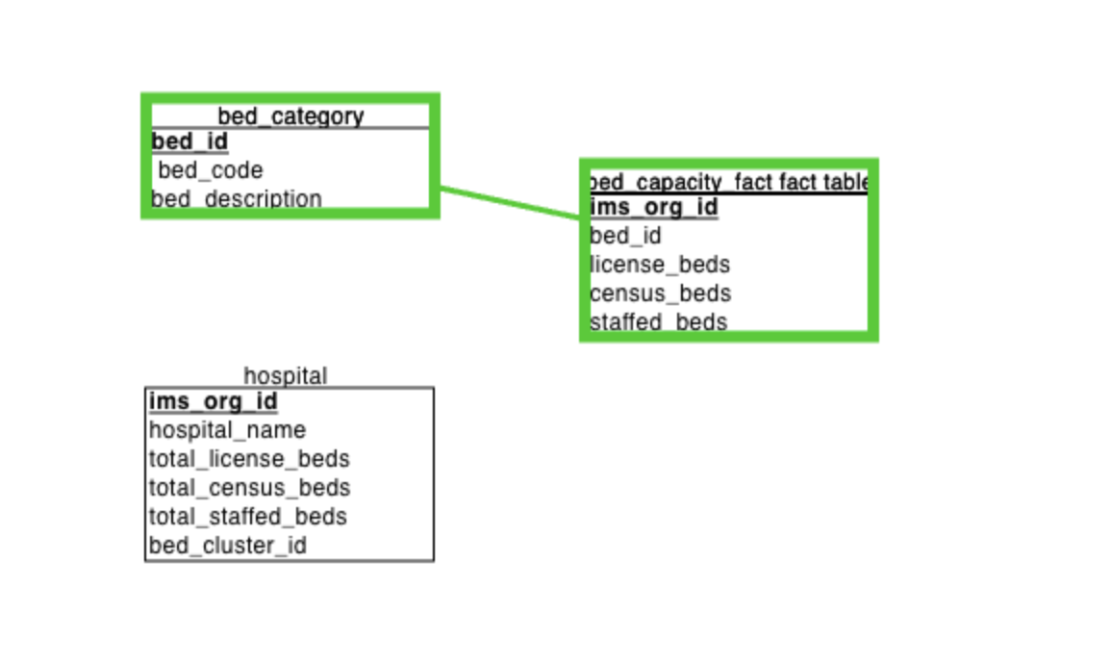

Setting Referential Integrity with Foreign Keys

Once the connections were made, ERDPlus automatically generated foreign key (FK) constraints in the bed_capacity_fact table:

ims_org_id from the hospital table became a foreign key in the bed_capacity_fact table, ensuring that each record in the fact table is associated with a valid hospital.

bed_id from the bed_category table was added as a foreign key in the bed_capacity_fact table, ensuring that each record corresponds to a specific bed type.

Final Star Schema Structure

The resulting schema, Healthcare_Bed_Capacity, consists of three key entities: Hospital (dimension), Bed Category (dimension), and Bed Capacity Fact (fact). These entities are interconnected, forming a star schema that provides a robust foundation for querying bed capacity and utilisation data across hospitals.

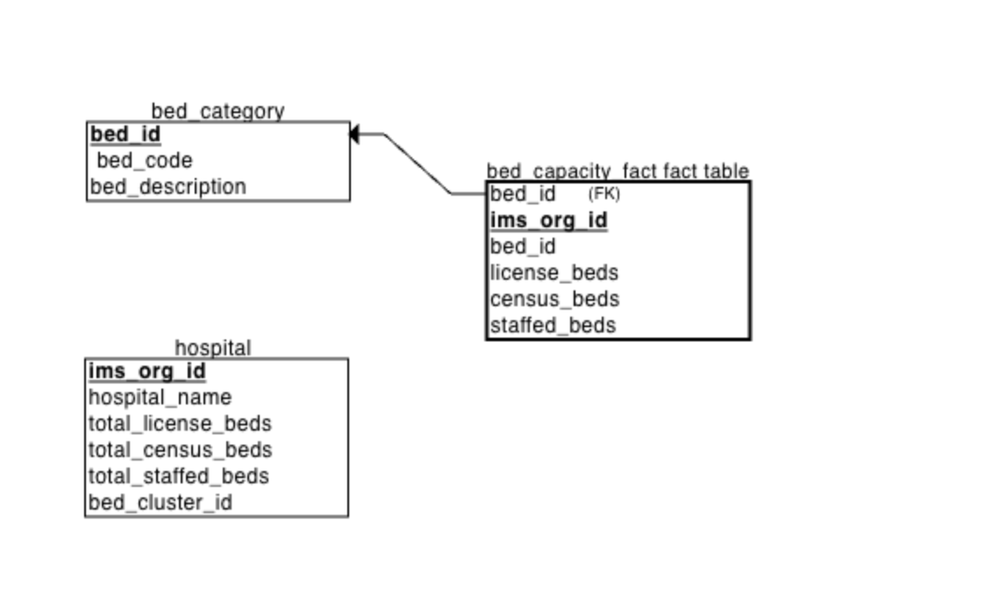

Connecting the Hospital Table to the Fact Table:

I selected the hospital table (dimension) and connected it to the bed_capacity_fact table (fact). This connection established a relationship between the primary key ims_org_id in the hospital table and its corresponding foreign key in the bed_capacity_fact table, ensuring that each record in the fact table corresponds to a valid hospital.

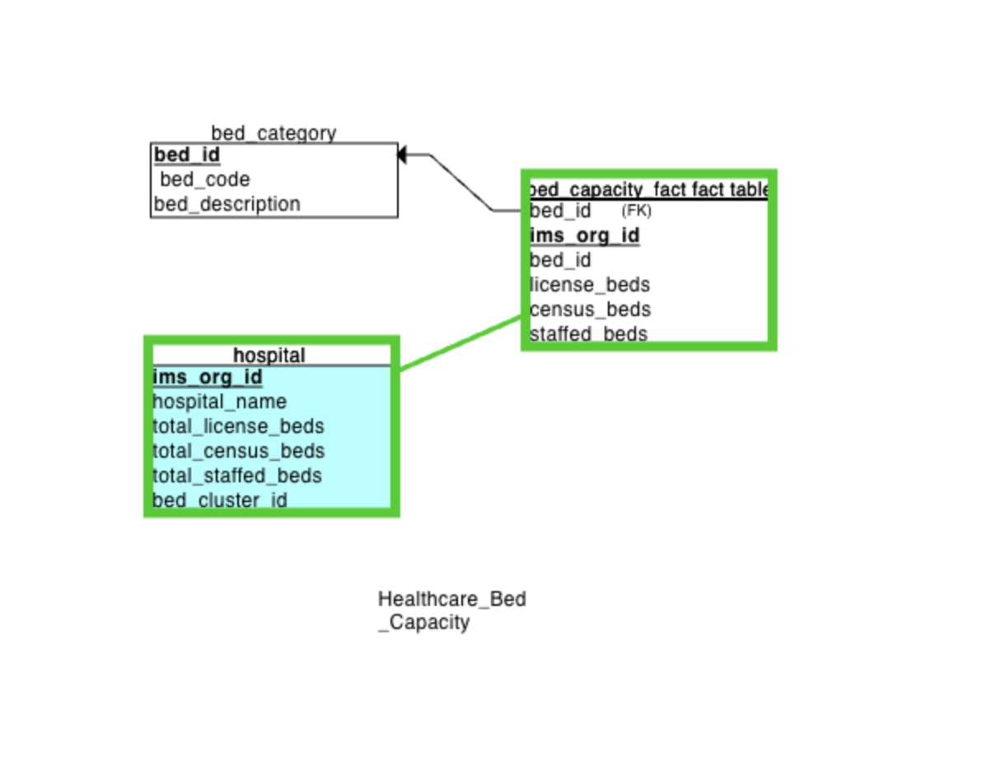

**Entities in the Star Schema:**

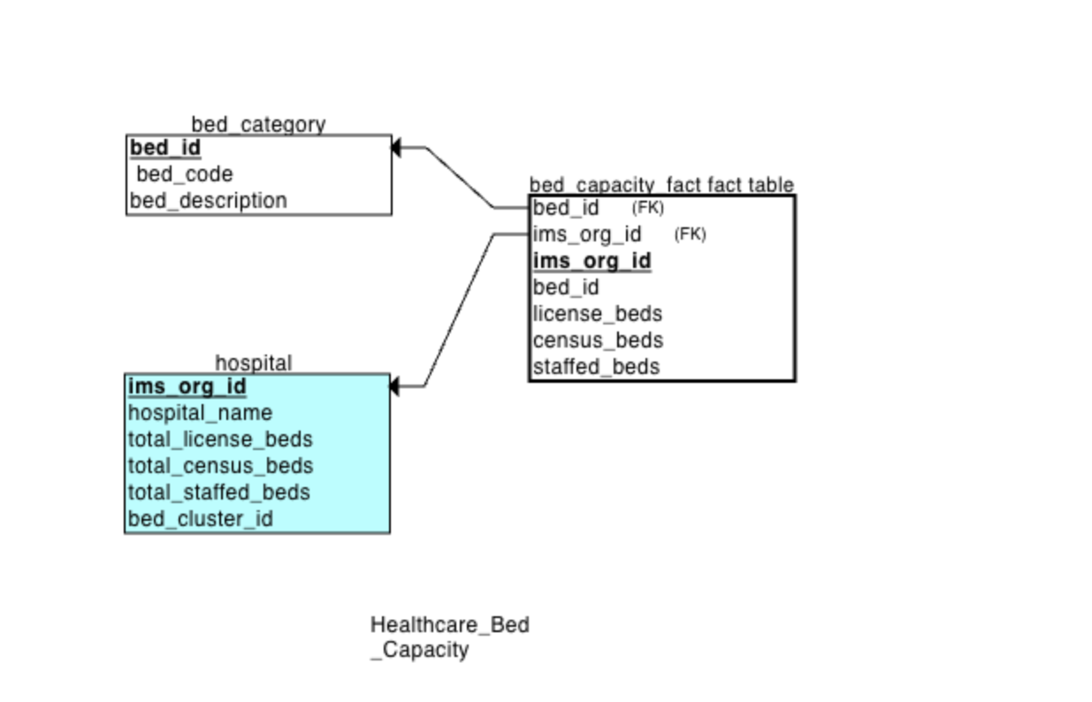

**Bed Category Table (Dimension 1):**

Primary Key: bed_id – A unique identifier for each bed type.

Attributes:

bed_code: A short code representing the type of bed (e.g., ICU, SICU).

bed_description: A detailed description of the bed category (e.g., Intensive Care Unit, Surgical Intensive Care Unit).

**Hospital Table (Dimension 2):**

Primary Key: ims_org_id – A unique identifier for each hospital or healthcare organisation.

Attributes:

hospital_name: The name of the hospital or medical facility.

total_license_beds: The total number of licensed beds authorised for the hospital.

total_staffed_beds: The number of beds that are currently staffed.

bed_cluster_id: An identifier for different clusters of beds within the hospital, aiding in organisational structure.

**Bed Capacity Fact Table (Fact Table):**

Attributes (Facts):

license_beds: The number of licensed beds for a specific hospital and bed type.

census_beds: The number of beds currently available for patient care.

staffed_beds: The number of beds that are staffed and ready for use.

Summary of the Star Schema Design:

The Healthcare_Bed_Capacity star schema has been thoughtfully designed to capture the relationships between hospitals, bed types, and bed capacity in a clear and structured manner. Each Hospital can have multiple types of beds, and the fact table tracks the capacity and utilisation of these beds across various categories. The implementation of foreign keys between the dimension tables and the fact table ensures data integrity and enables efficient querying for hospital bed utilisation analytics.

This schema can be utilised to analyse key metrics such as:

1.Comparison of total licensed beds versus actual staffed beds.

2.Bed occupancy rates across different types of beds (e.g., ICU, general wards).

3.Performance metrics at both the hospital and bed level concerning capacity and utilisation.

**Task 4:**

**Step 1: Creating the Database.**

The first step is to create the database where all tables will be stored. Execute the following SQL command:

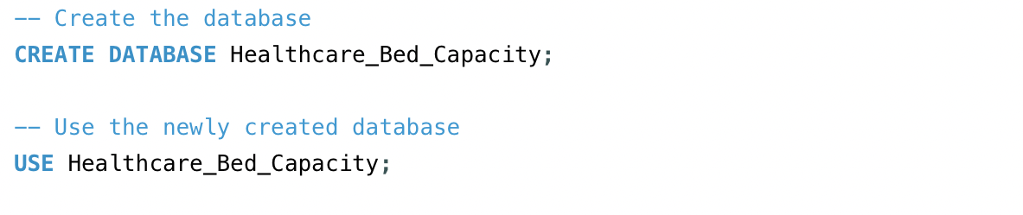

This creates and selects the Healthcare_Bed_Capacity database as the active environment for building the schema and running queries.

**Step2:Create the Bed Category Dimension Table**

The bed category dimension table stores bed types (e.g., ICU, SICU) and their respective codes.

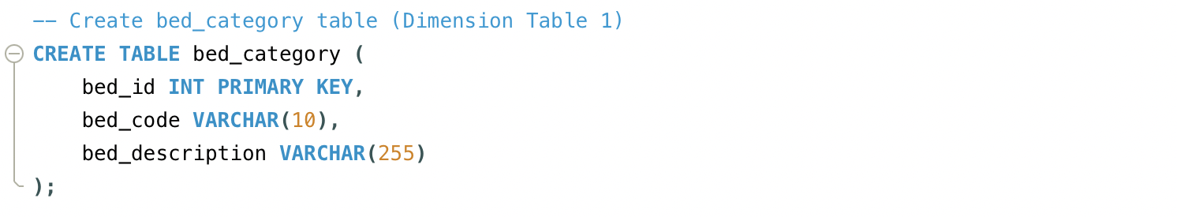

Step2.1:

After i refreshed i moved forward to data Import for this table.And clicked on refresh all for the tables to load in the tables section

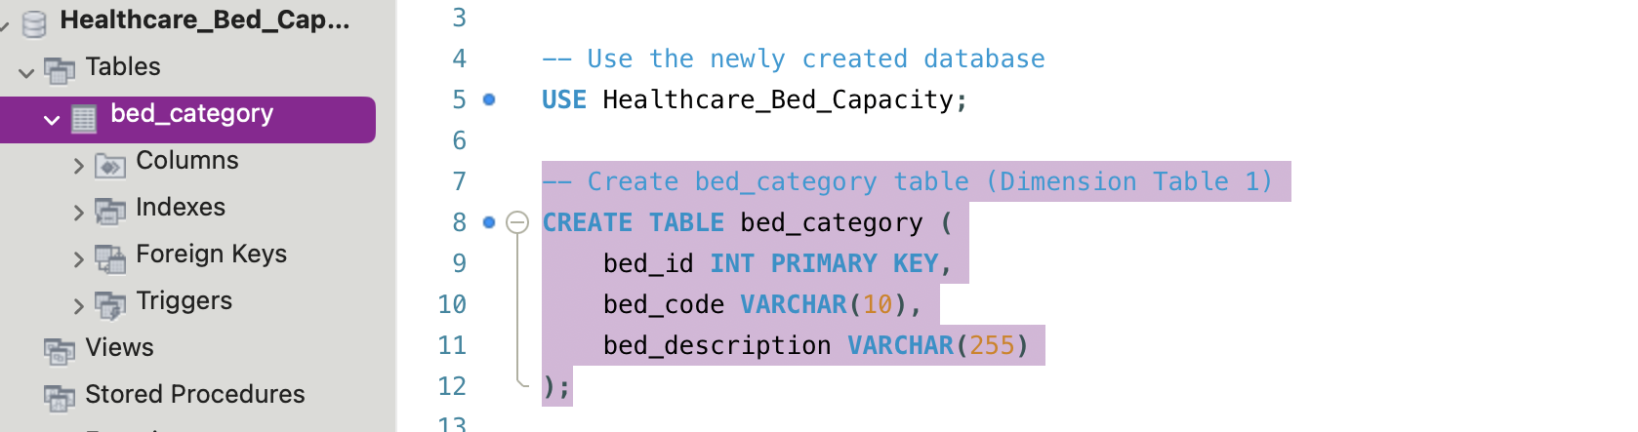

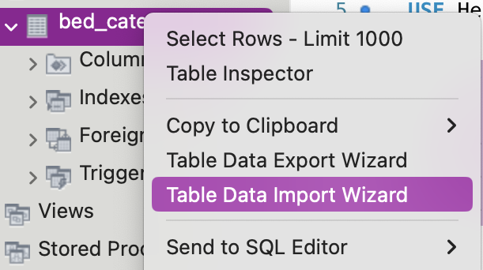

Step 2.2:

I clicked Browse and selected the bed_type.csv file I downloaded for this assignment, in the select file page.

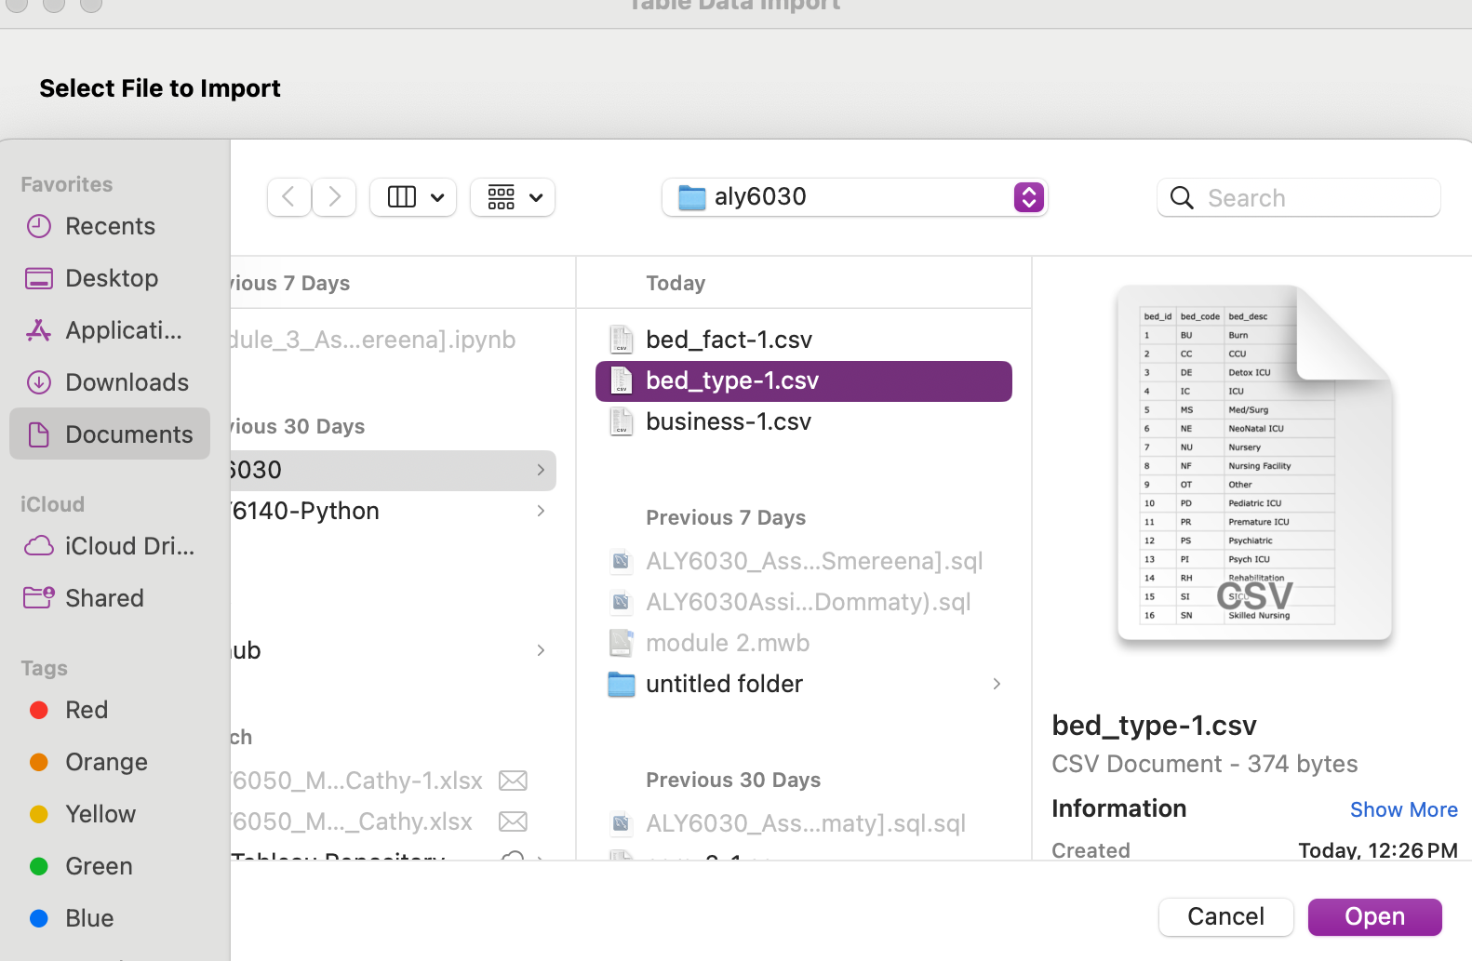

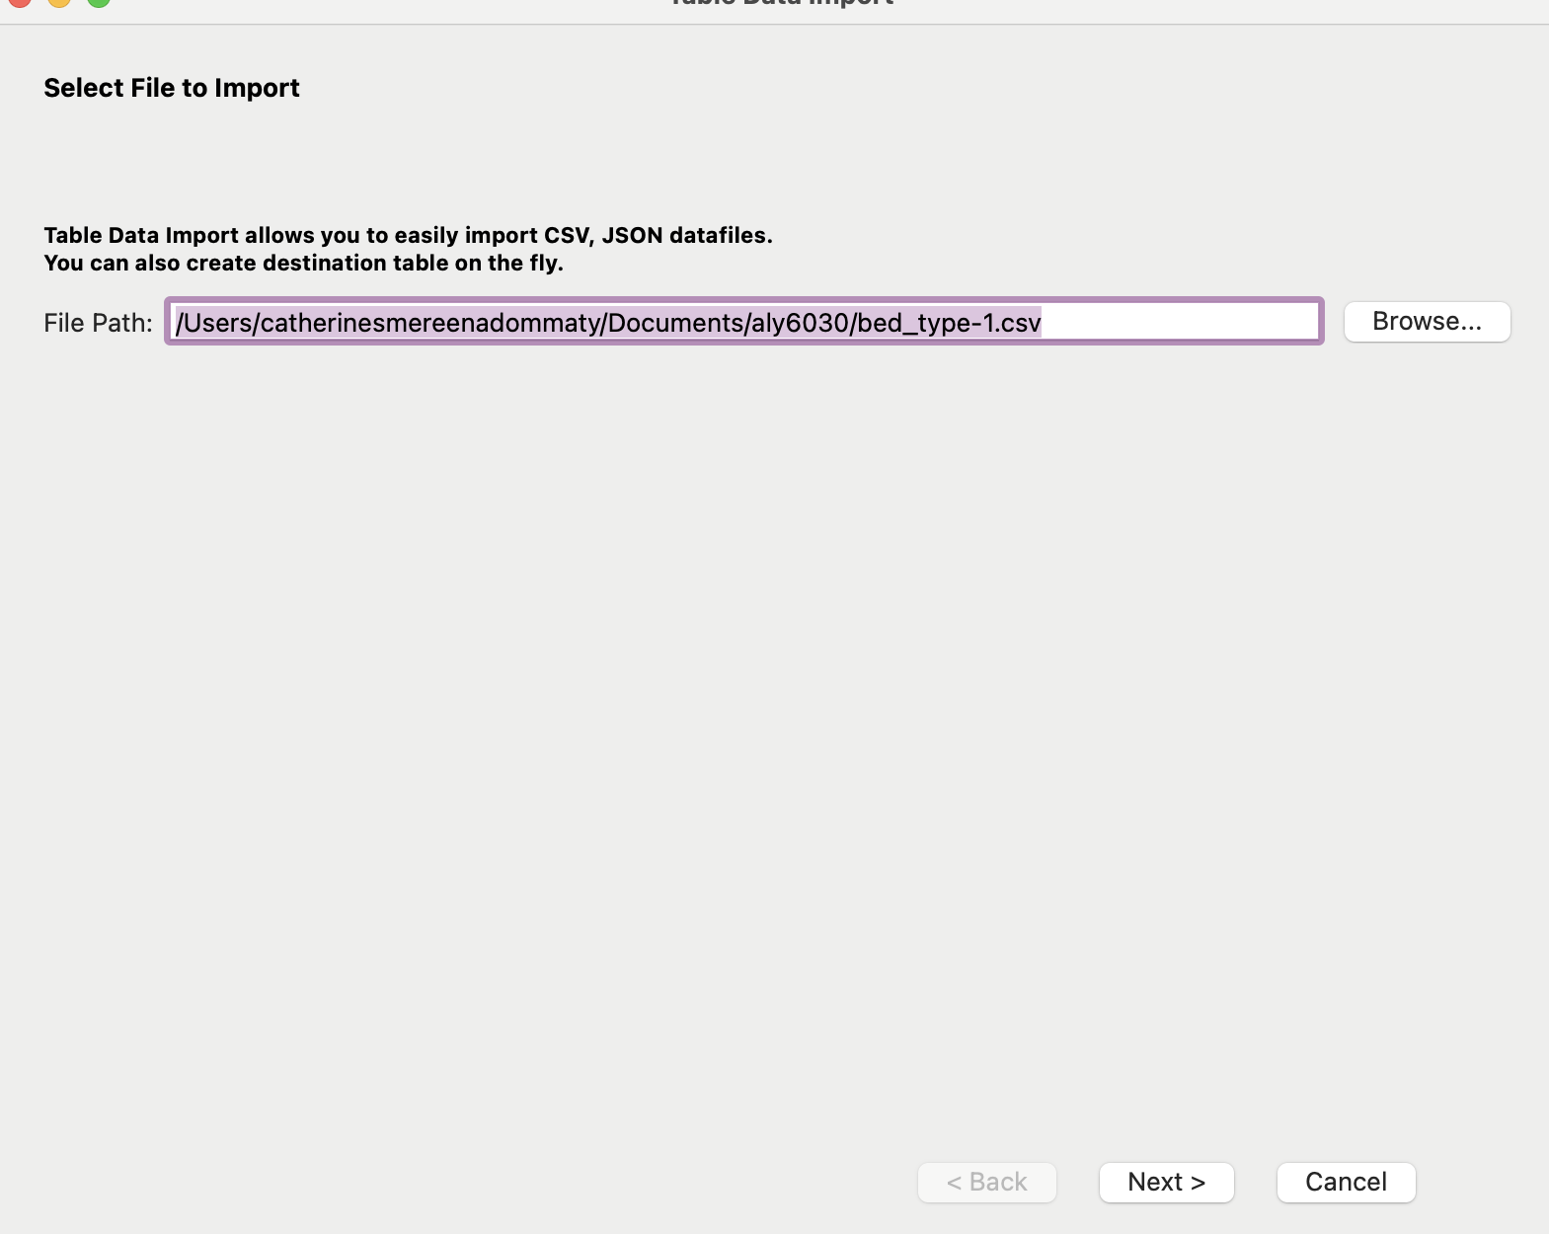

Step2.3:After selecting the file to import, I chose to use the existing table option to select the business table I created in MySQL as the destination to import the dataset.

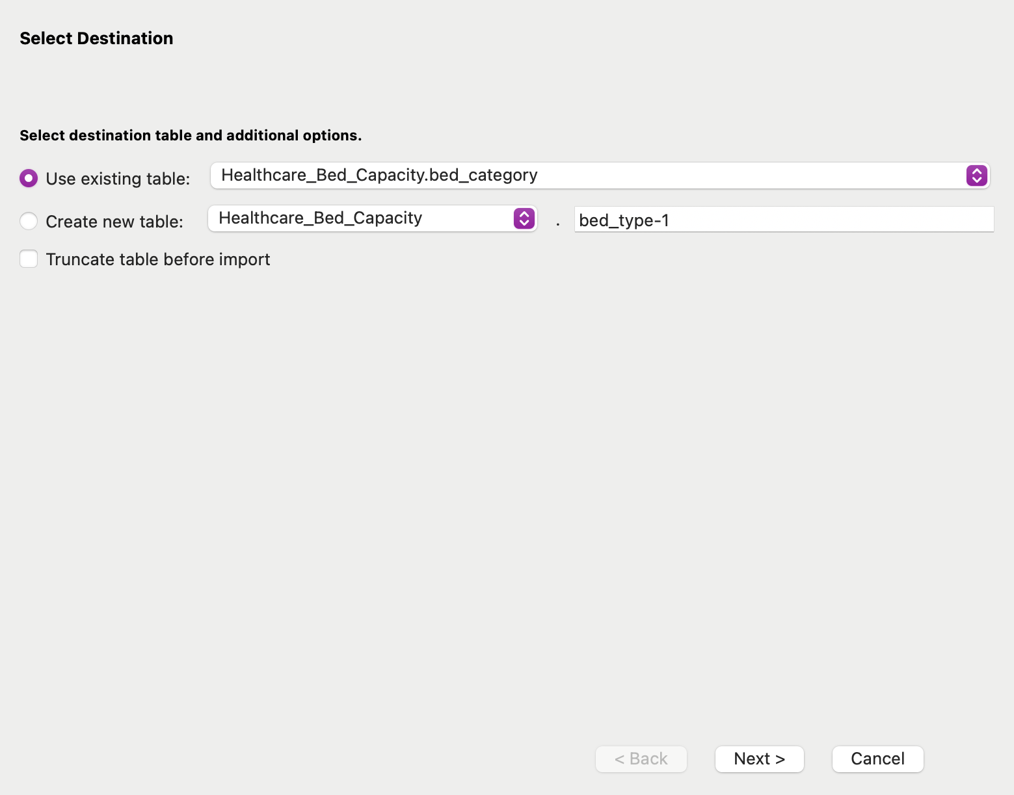

Step2.4:As I proceeded with the import process of my CSV file, the wizard prompted me to map the CSV columns to the corresponding columns in my business table. This step is critical to ensure that the data is accurately transferred and structured in the database.

I carefully reviewed the mappings to verify that each field from the CSV file aligned correctly with the appropriate column in the database table. This involved checking

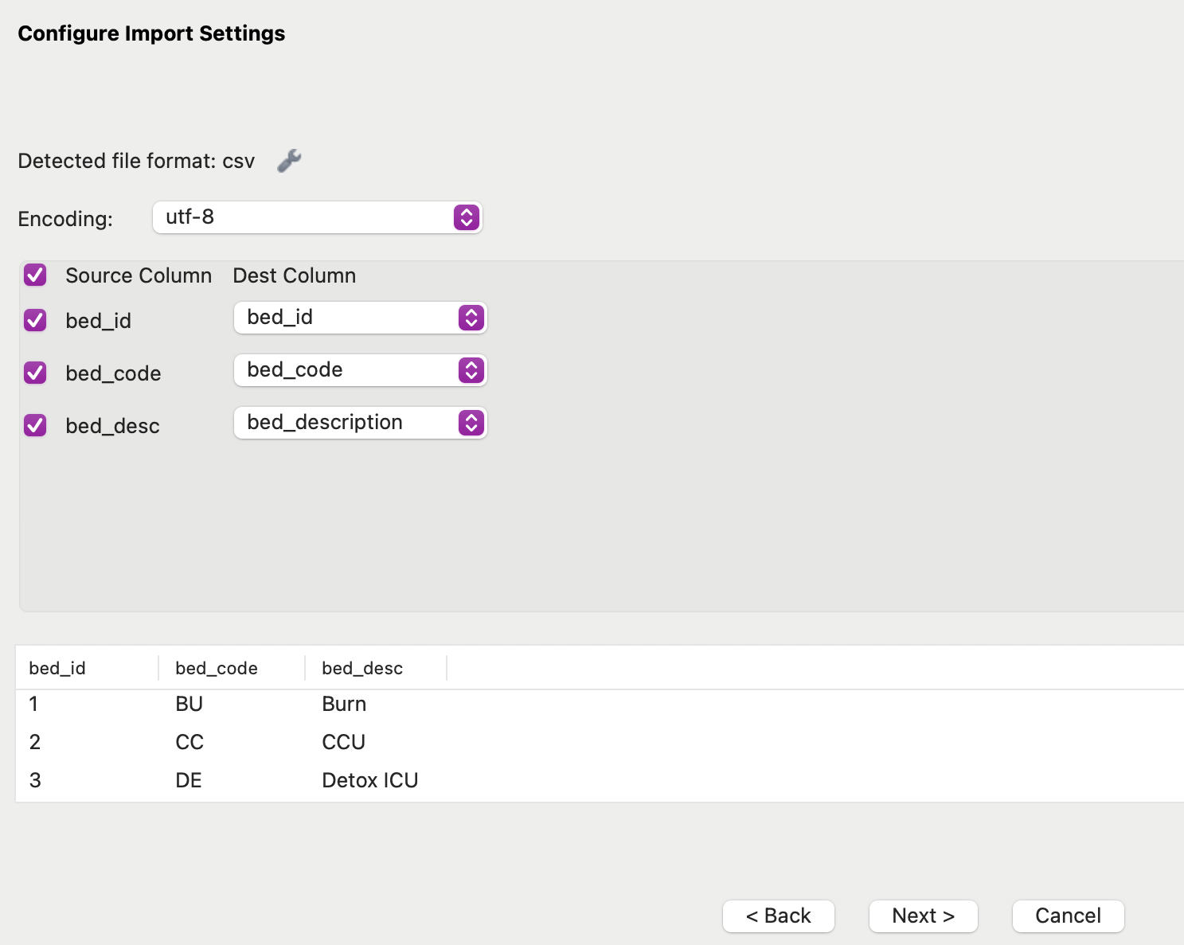

Step2.5: Once I confirmed that all the columns were correctly mapped, I clicked Next to initiate the import process. MySQL Workbench then processed the CSV file and inserted the rows into the business table.

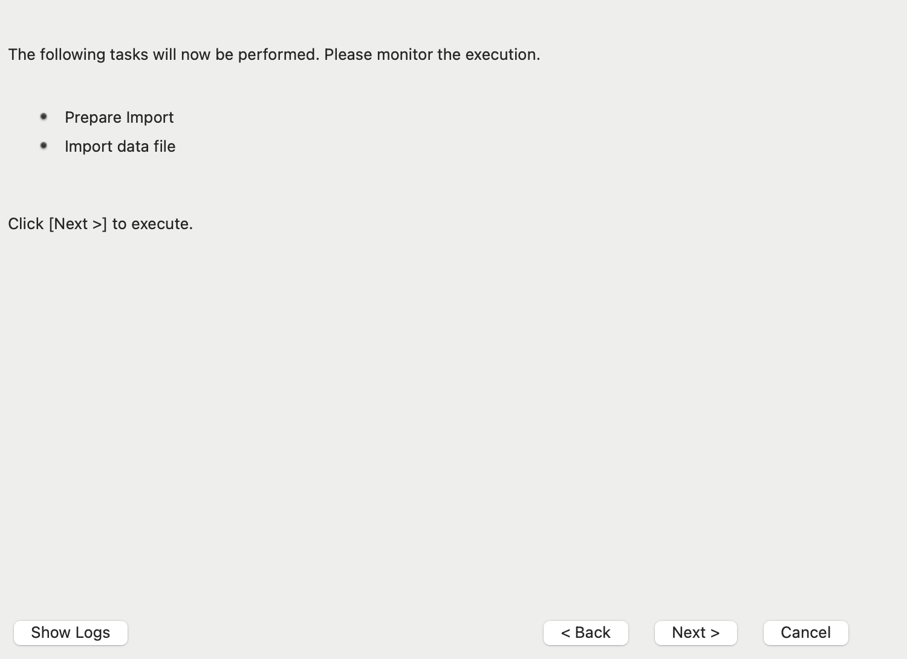

Step2.6:After the import was completed, I conducted a thorough review of the data to ensure that everything had been inserted correctly. This included checking for any discrepancies, such as missing values or incorrect data types.

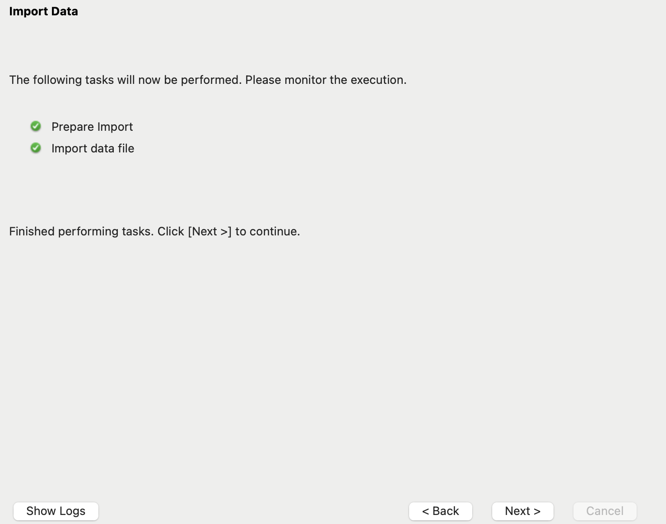

Step2.7:Upon completing my verification, I found that a total of 20 Records had been successfully imported into the business table. This successful import represents a significant amount of data that can now be utilised for analysis within the database.

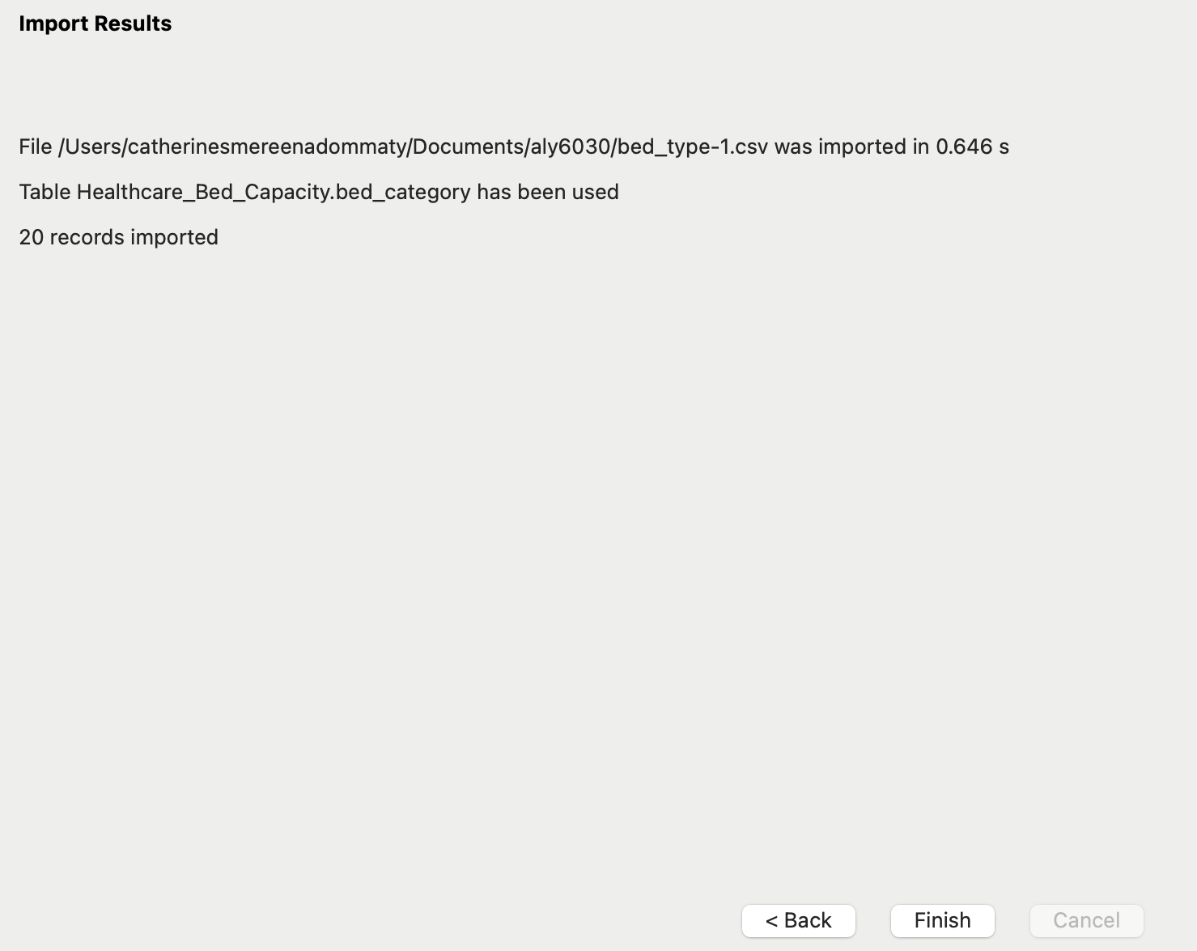

**Step3: Create the Hospital Dimension Table**

The hospital dimension table stores details such as hospital name, total licensed beds, census beds, staffed beds, and bed cluster identifiers.

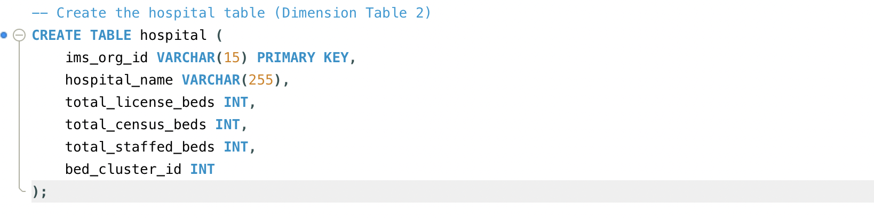

Step 3.1:Importing Data into the Business Table

In this step, I imported data into the business dimension table, which contains essential details about each hospital or medical centre. This table includes the organisation's unique identifier (ims_org_id), the business name, and the total number of licensed, census, and staffed beds. I assigned ims_org_id as the primary key to ensure that each business is uniquely identified, which is crucial for establishing relationships within the star schema model.

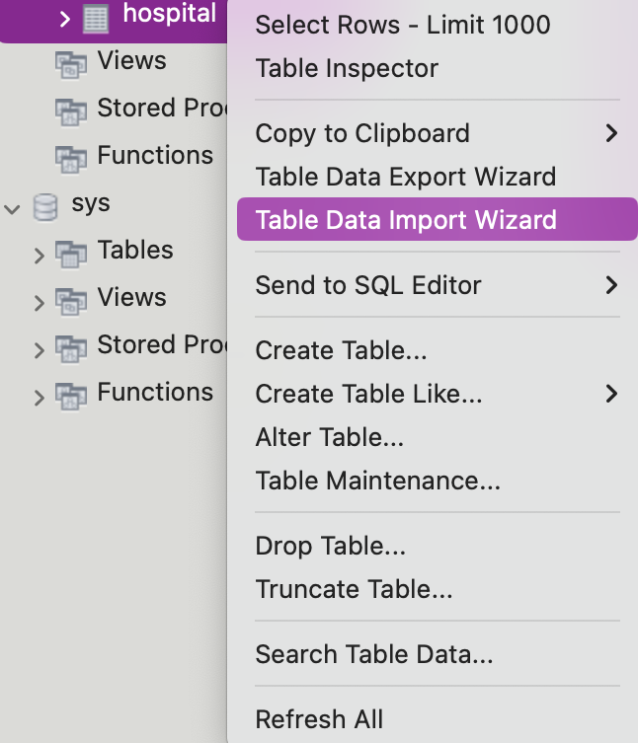

Step3.2:I clicked Browse and selected the business.csv file I downloaded for this assignment, in the select file page.

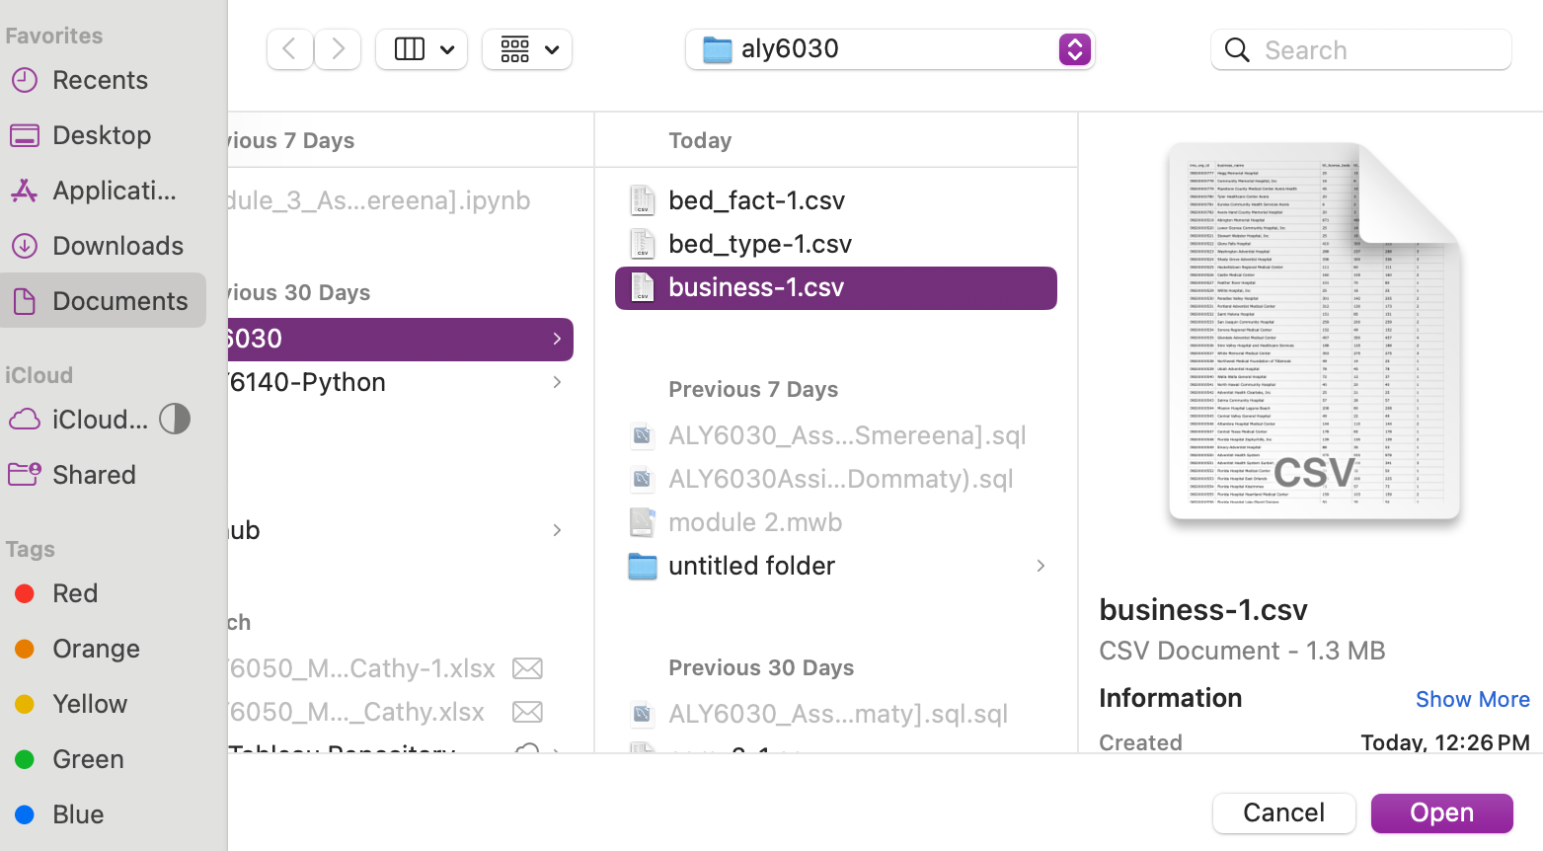

Then i selected file to import and pressed next.

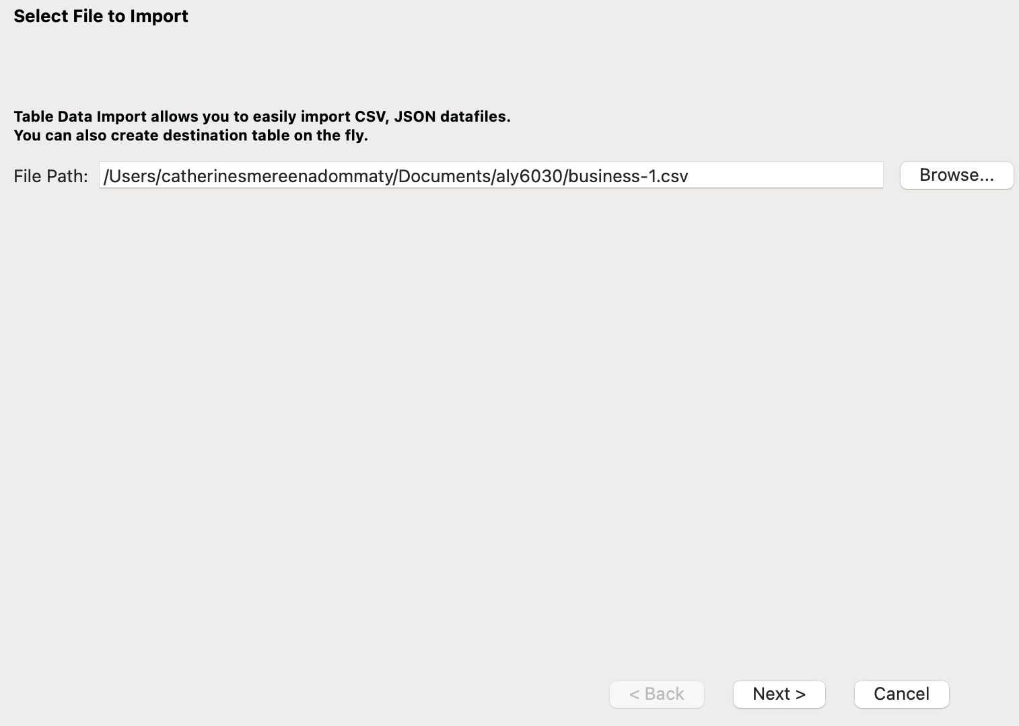

Step3.3:Mapping CSV Columns to Database Columns:

Since I was importing a CSV file, the wizard prompted me to map the CSV columns to the corresponding columns in my business table. I carefully reviewed the mappings to ensure that each field in the CSV matched the correct column in the database table.

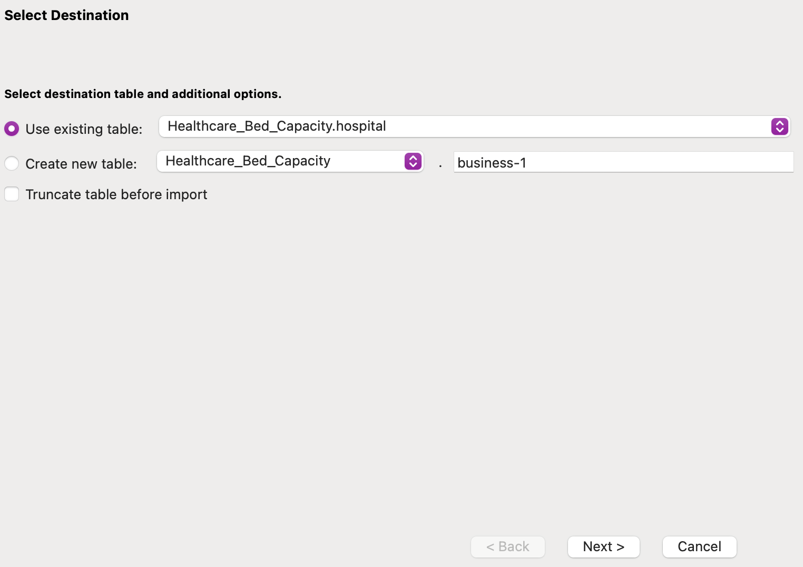

Step3.4:Starting the Import Process:

Once I confirmed that all columns were correctly mapped, I clicked Next to start the import process.

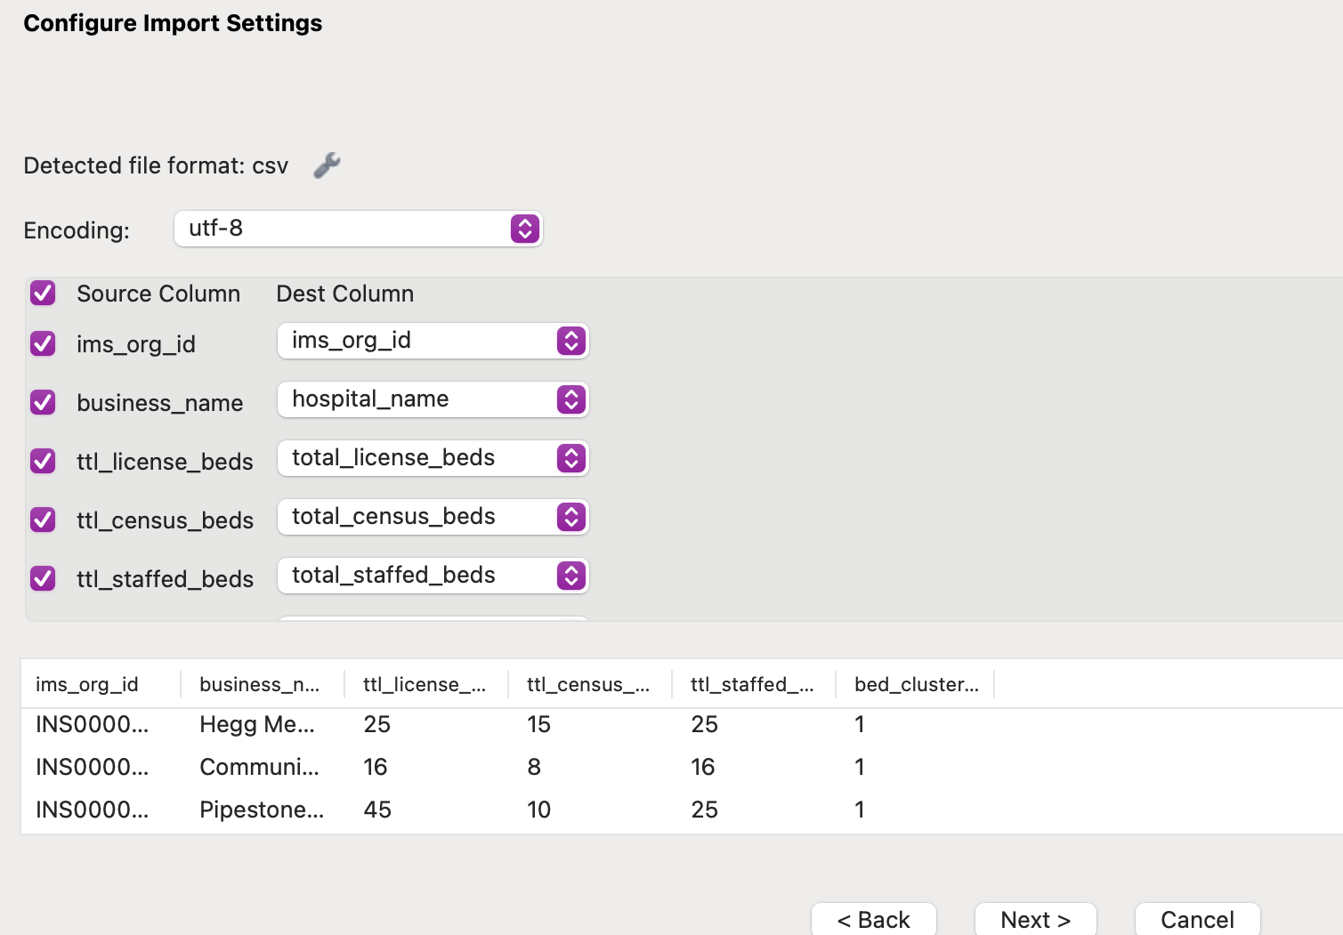

Step3.5:Processing the Import:MySQL Workbench processed the file and inserted the rows into the business table.

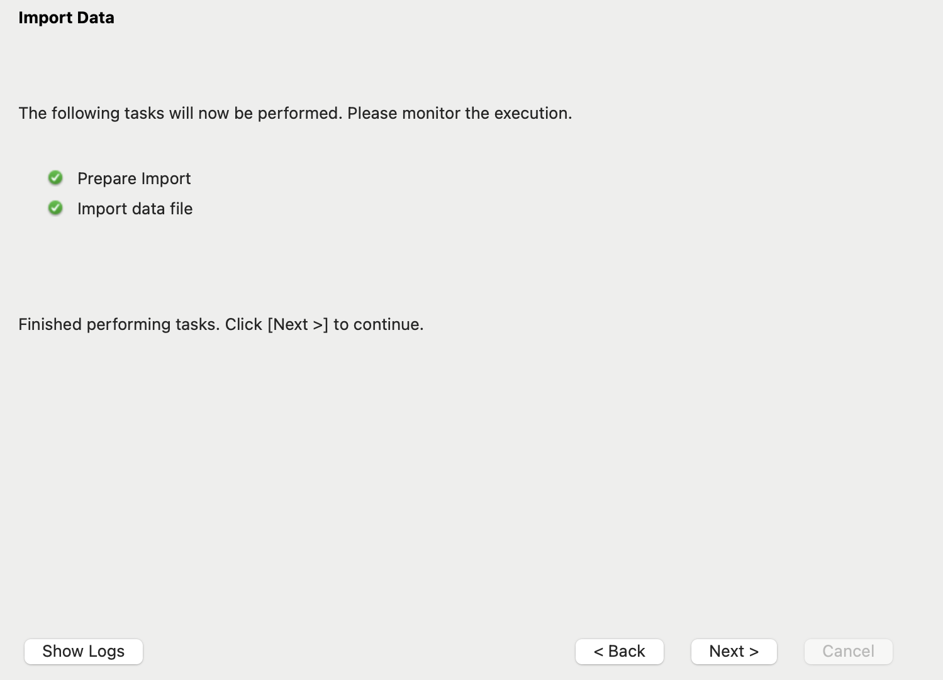

Step3.6:Verifying the Imported Data:

After the import was complete, I double-checked the data to ensure it was correctly inserted into the table.

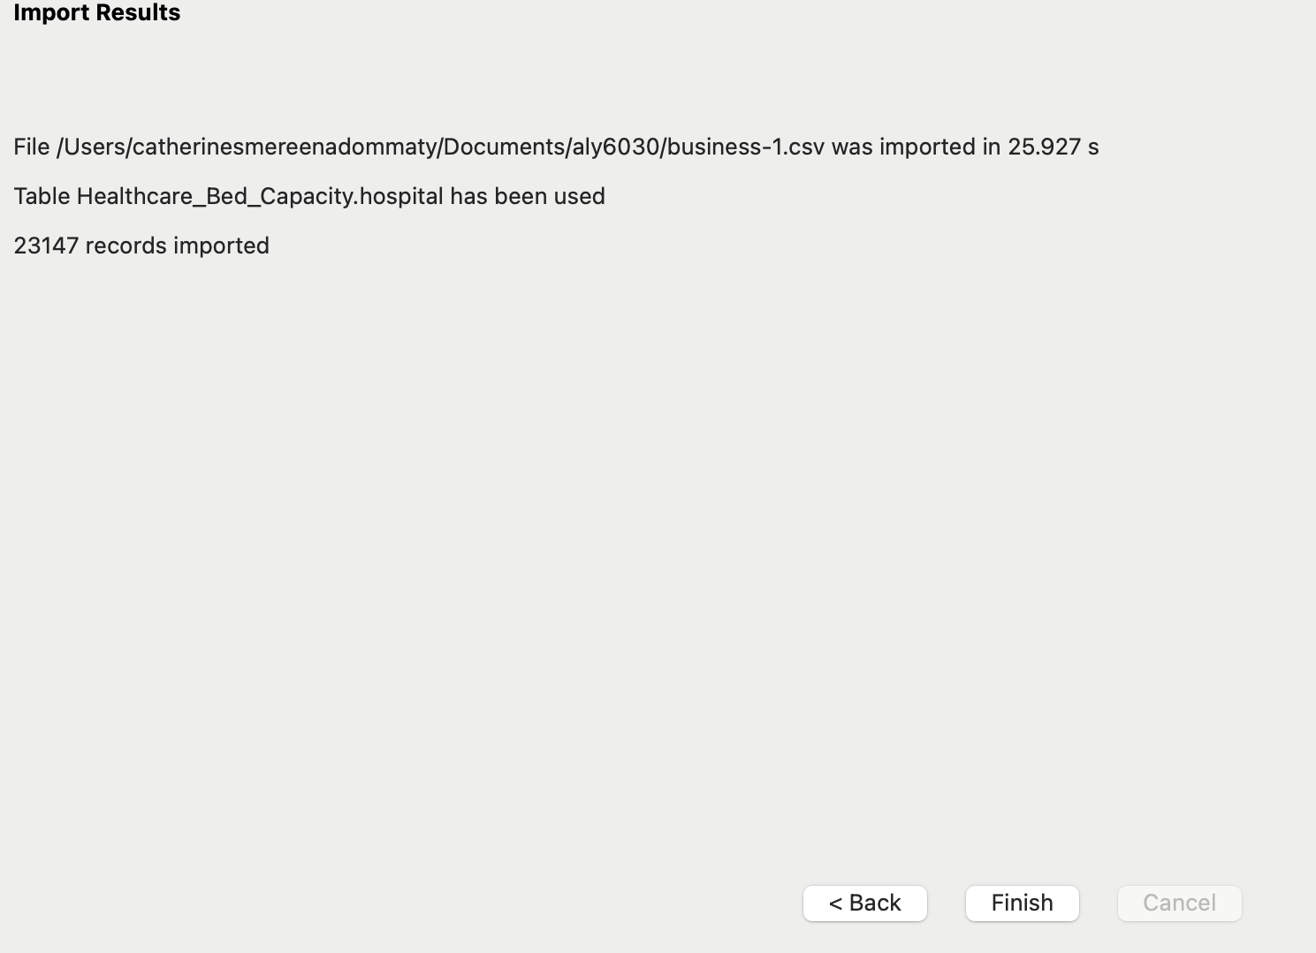

Upon verification, I found that a total of 23,147 records had been successfully imported into the business table.

**Step4: Create the Bed Capacity Fact Table**

The bed capacity fact table captures bed-related facts such as licensed, census, and staffed beds for each hospital and bed type.

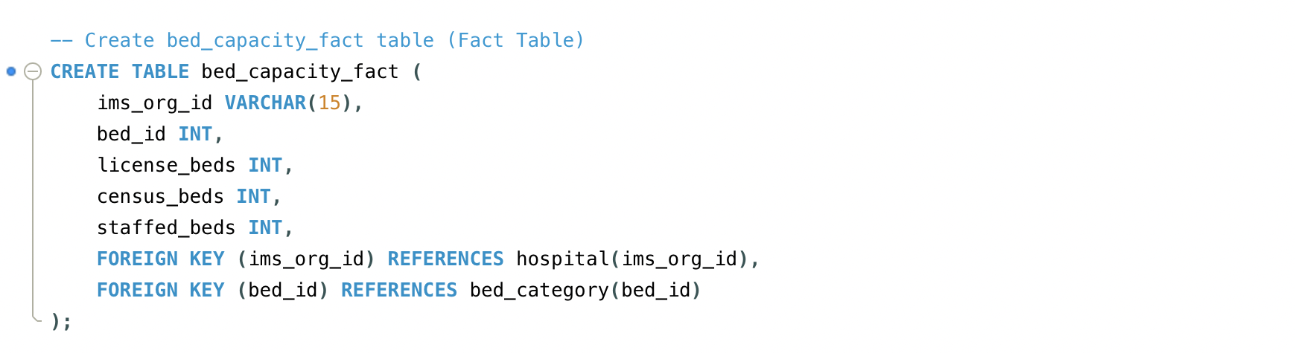

Step4.1: Importing Data into the Bed Fact Table

The next step involved creating the bed_fact table, which serves as the central fact table in my star schema. To facilitate this, I used the following SQL query to define the structure of the table.

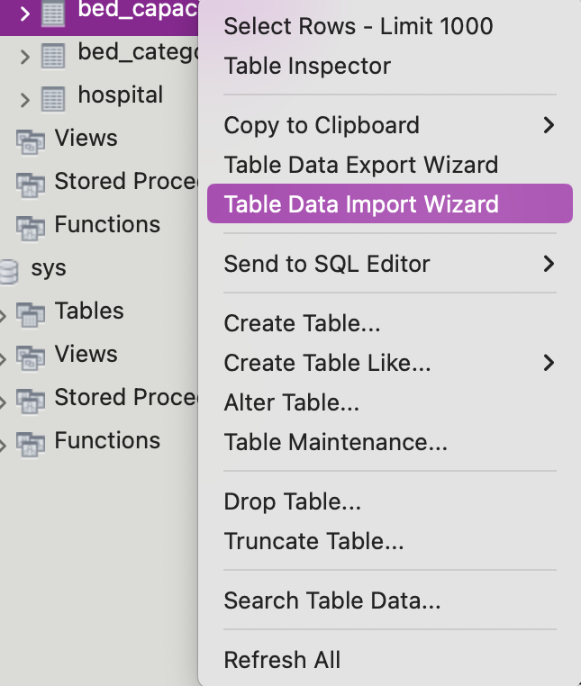

After setting up the table, I proceeded to import data into the bed_fact table using the Data Import Wizard in MySQL Workbench.

Step 4.2:Selecting the CSV File:

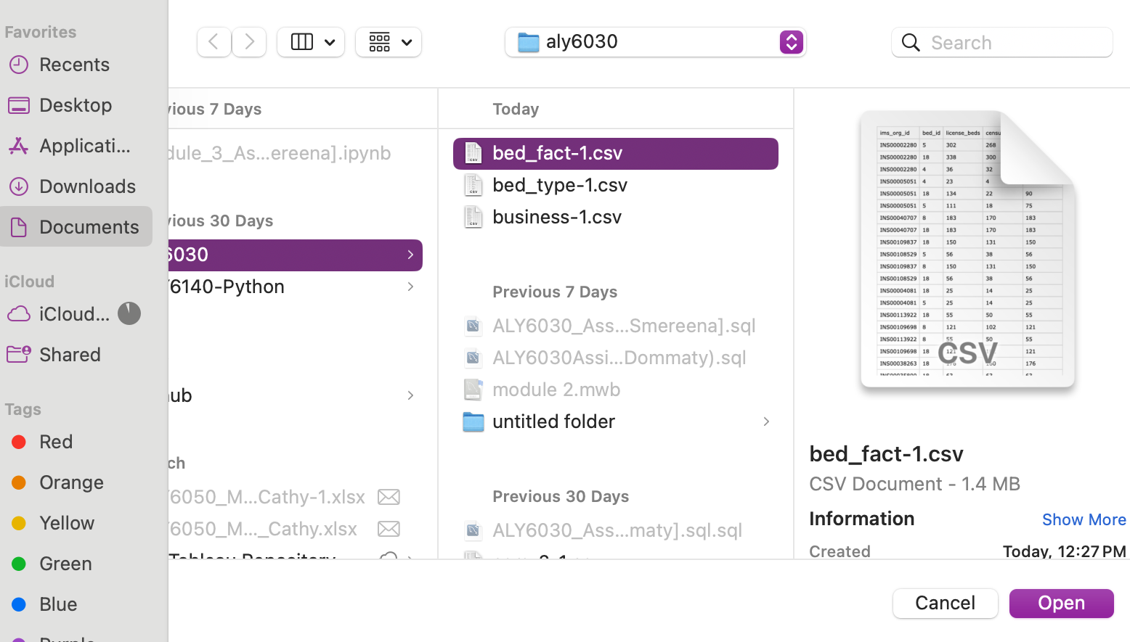

In the import wizard, I navigated to the Select File to Import page and chose the bed_fact-1.csv file from my downloads.

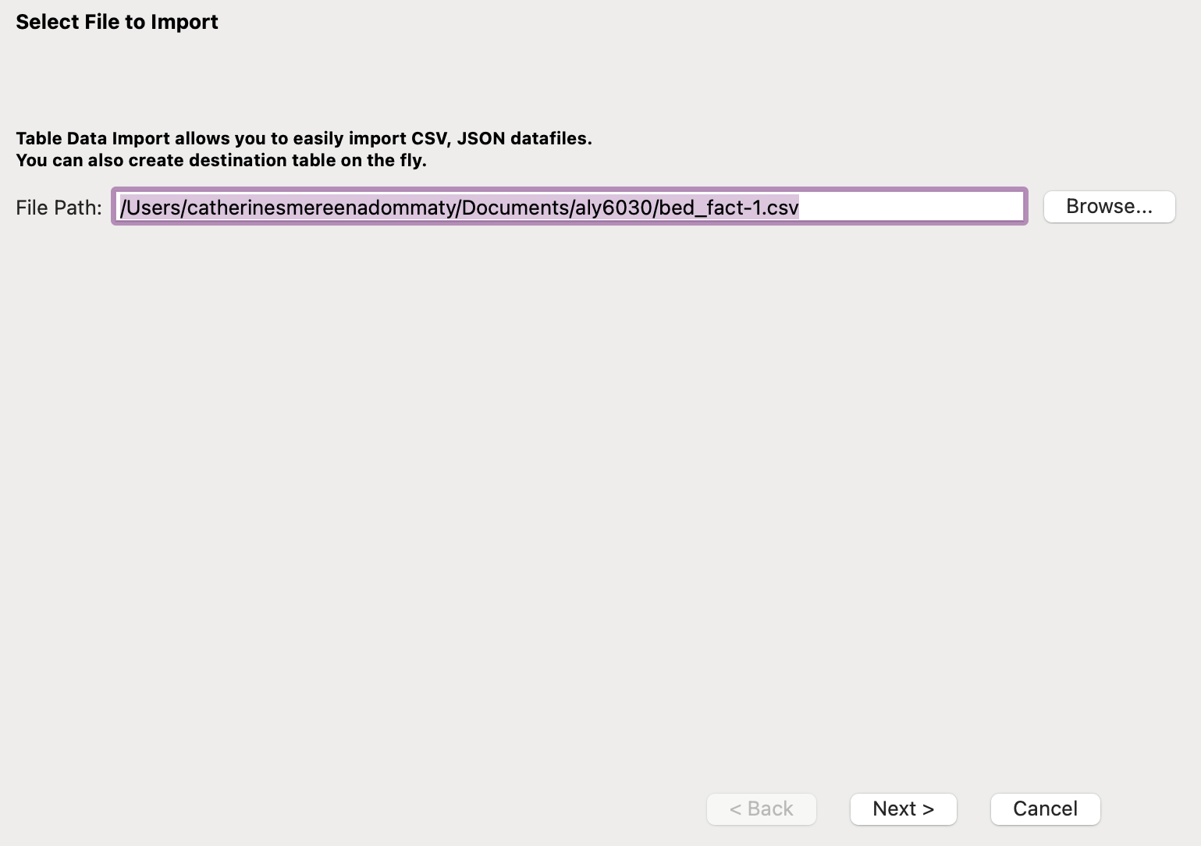

Step4.3:Choosing the Destination Table:

- After selecting the file, I opted for the Use Existing Table option, specifying the bed_fact table I had previously created in MySQL as the destination for the dataset.

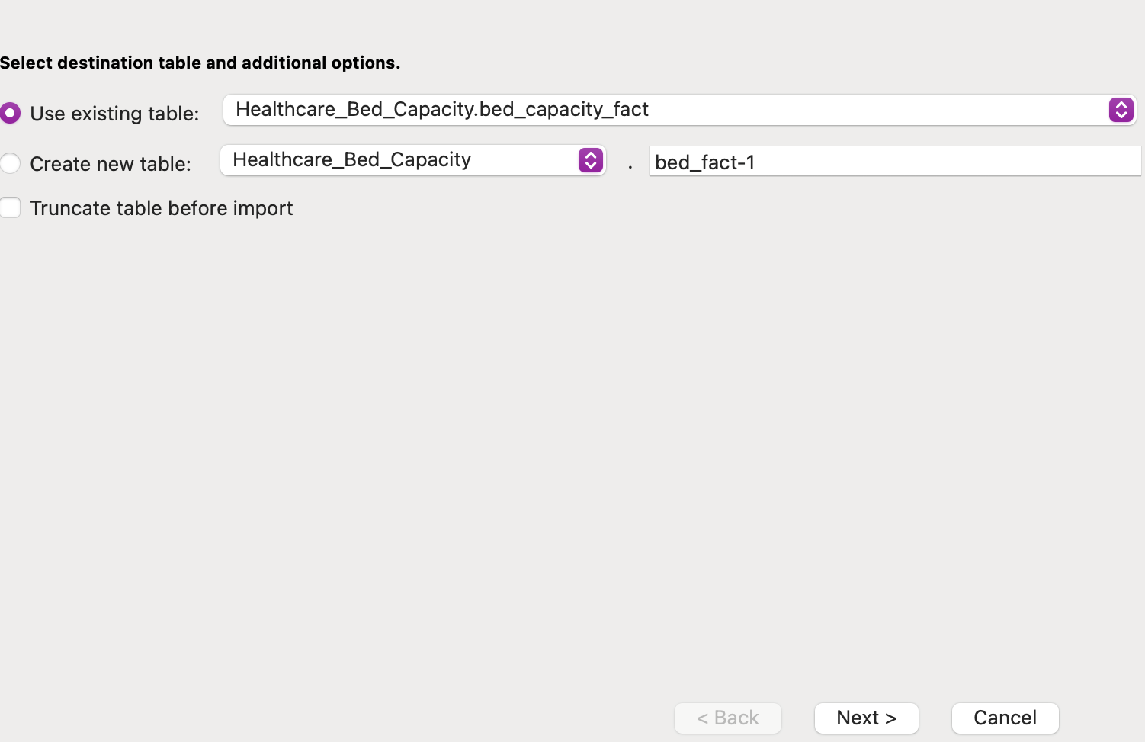

Step4.4:Mapping CSV Columns:

- The wizard prompted me to map the columns from the CSV file to the corresponding columns in the bed_fact table. I took the time to carefully review these mappings to ensure that each field in the CSV was correctly matched to its respective column in the database table.

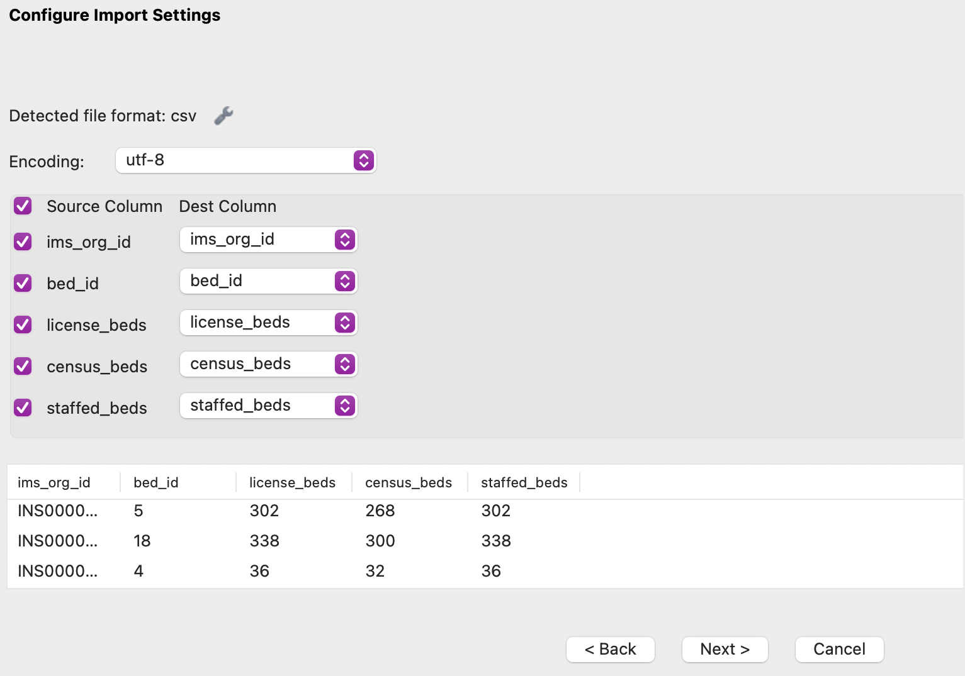

Step4.5:Starting the Import Process:

- Once I confirmed that all mappings were accurate, I clicked Next to initiate the import.

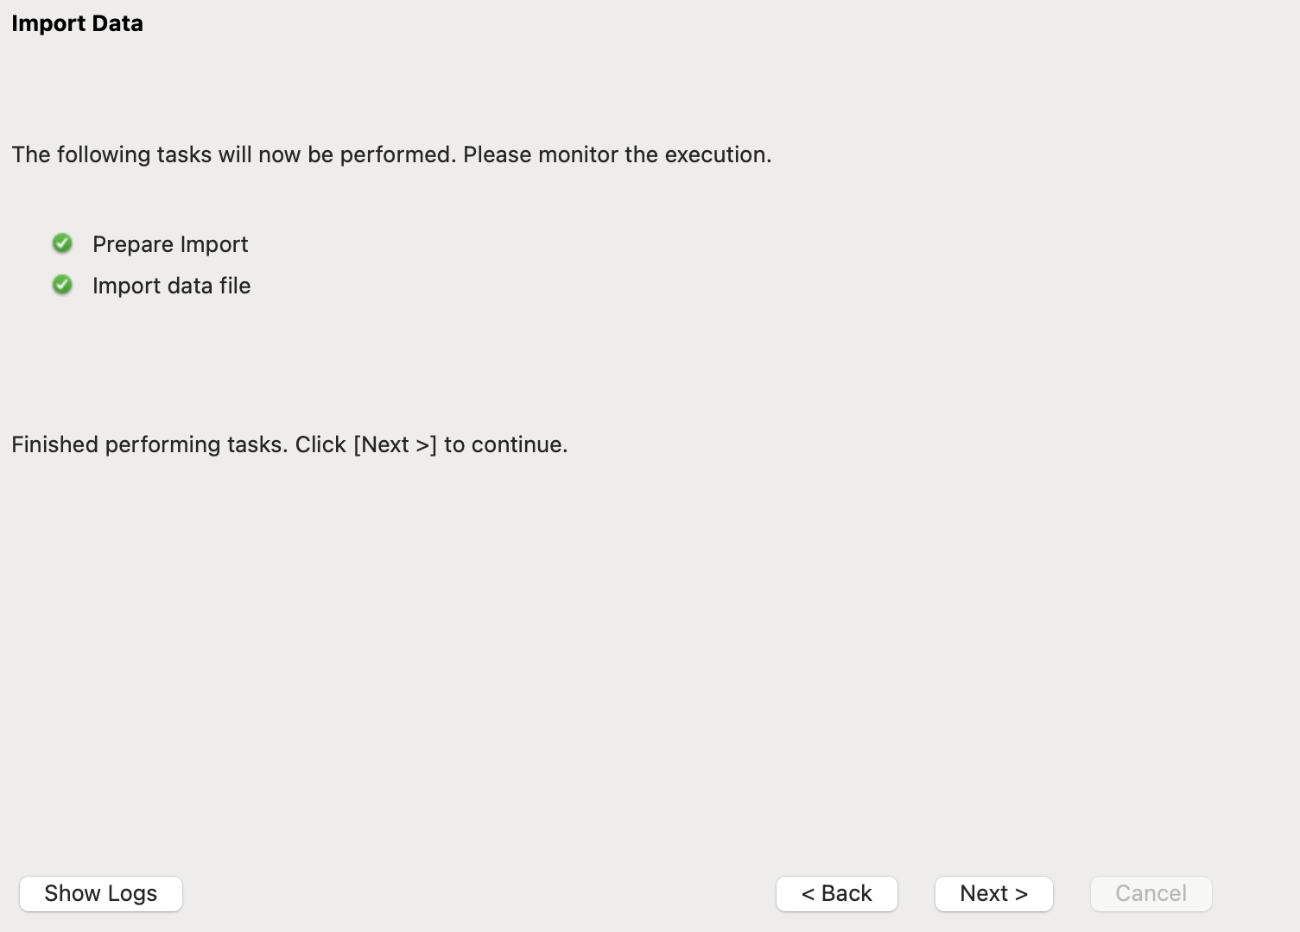

Step4.6:Processing the Import:

- MySQL Workbench then processed the file and inserted the rows into the bed_fact table.

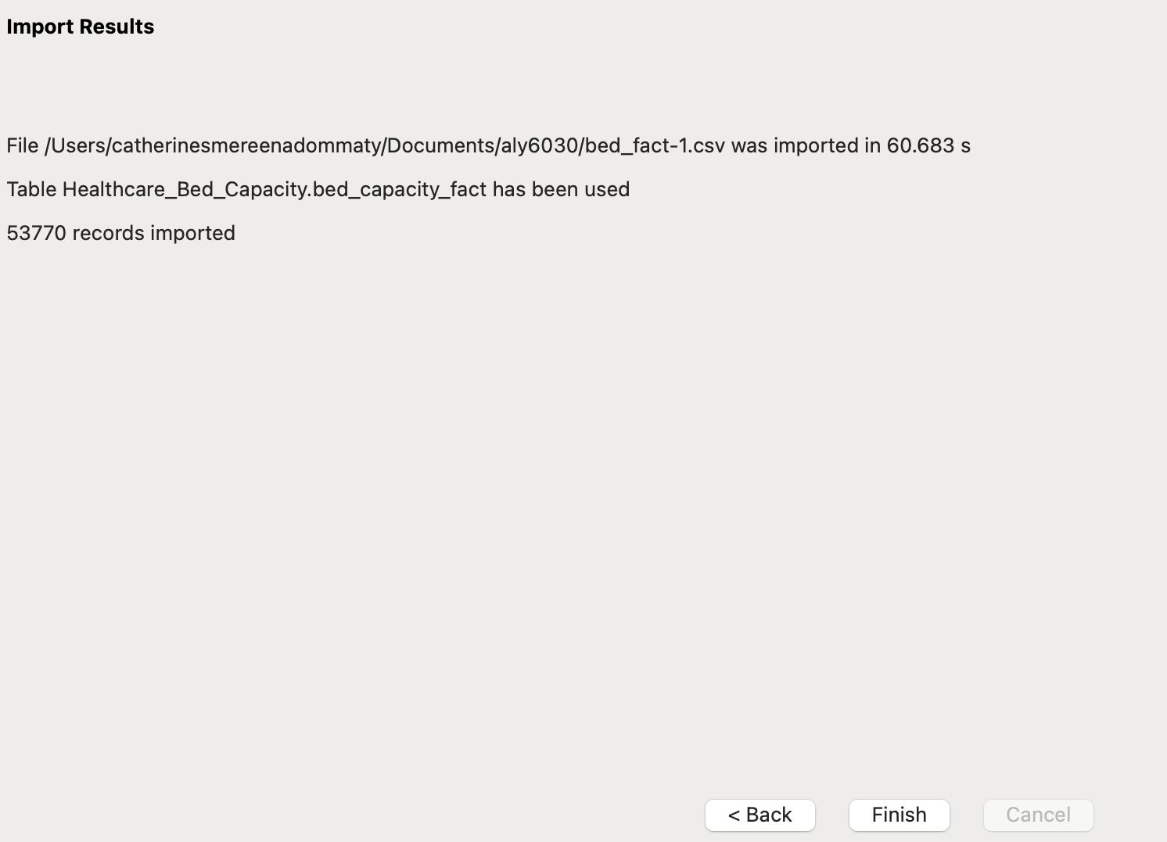

After the import was complete, I checked the data to ensure it had been correctly inserted.

Reviewing the Results:

- I was pleased to find that a total of 53,770 records had been successfully imported into the bed_fact table.

This process ensured that the bed_facttable was populated with accurate data, laying the groundwork for effective analysis and querying within the Healthcare_Bed_Capacity database.

Task5:

Query 1: Select All Records from the Fact Table



Description:

This query retrieves all records from the bed_capacity_fact table. This table serves as the fact table in your star schema, containing detailed information about bed capacities in various hospitals, including licensed, census, and staffed beds.

Each row will represent a record for a specific hospital (identified by ims_org_id) and bed type (identified by bed_id). You’ll see fields such as license_beds, census_beds, and staffed_beds.

Query 2: Count of Records per ims_org_id with More Than One Record

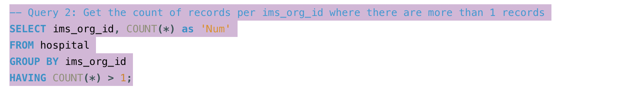

Description:

This query counts how many records exist in the hospital table for each unique ims_org_id. It groups the results by ims_org_id and filters the results to show only those hospitals that have more than one record.

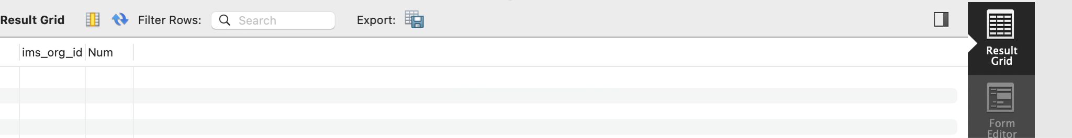

The output is list ims_org_id values along with the count of records (labeled as 'Num') for those IDs that appear more than once in the hospital table. If the output is empty, it indicates that every hospital has a unique identifier.

Query 3: Count of Hospitals by Name with More Than One Record

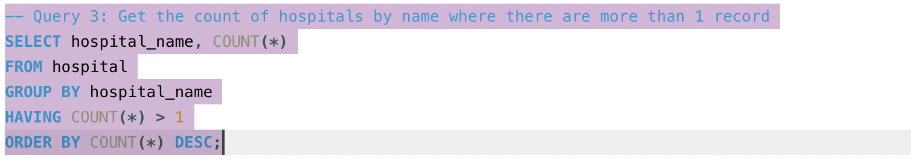

Description:

This query counts how many records exist for each hospital by their name in the hospital table. It groups the results by hospital_name and filters for hospitals that have more than one record, ordering the output by the count in descending order.

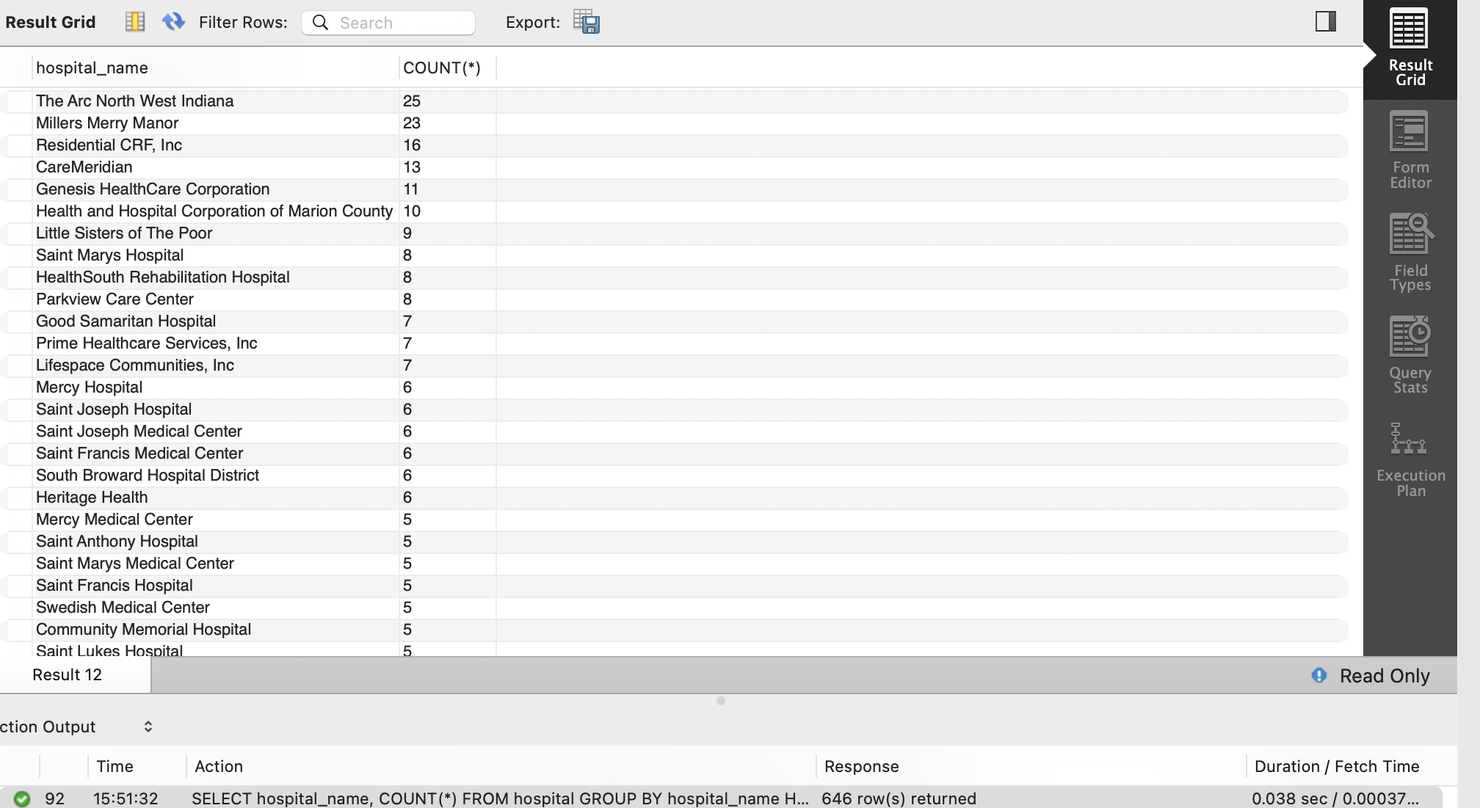

The output shows hospital_name along with the count of how many times that hospital name appears in the hospital table. If the list contains names, it suggests that some hospitals have duplicate entries in the database.

Query 4: Get ICU and SICU Bed Capacity Ordered by License Beds

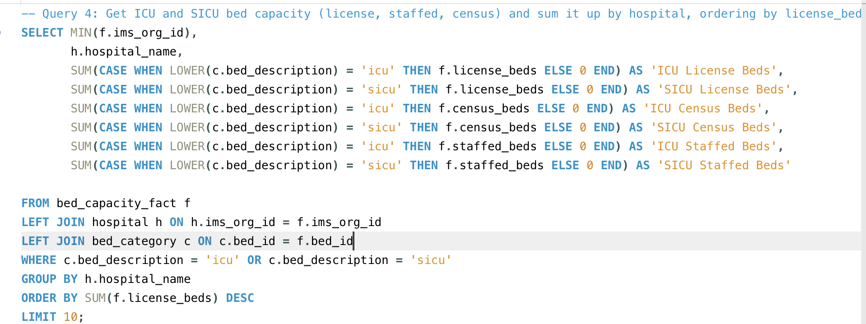

Description:

This query retrieves the total count of ICU and SICU bed capacities (licensed, census, and staffed) from the bed_capacity_fact table. It performs a LEFT JOIN with the hospital and bed_category tables to link hospital information and bed type descriptions. It uses CASE statements to calculate sums for each category, grouping by hospital name and ordering by the total licensed beds in descending order, limiting the output to the top 10 hospitals.

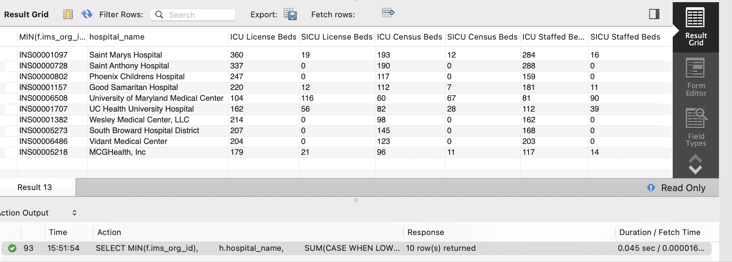

The output displays the top 10 hospitals ranked by licensed ICU and SICU beds. Each row will include the hospital's name, total licensed beds for ICU and SICU, total census beds for ICU and SICU, and total staffed beds for ICU and SICU. This helps identify hospitals with the highest capacity in critical care.

Query 5: Get ICU and SICU Bed Capacity Ordered by Census Beds

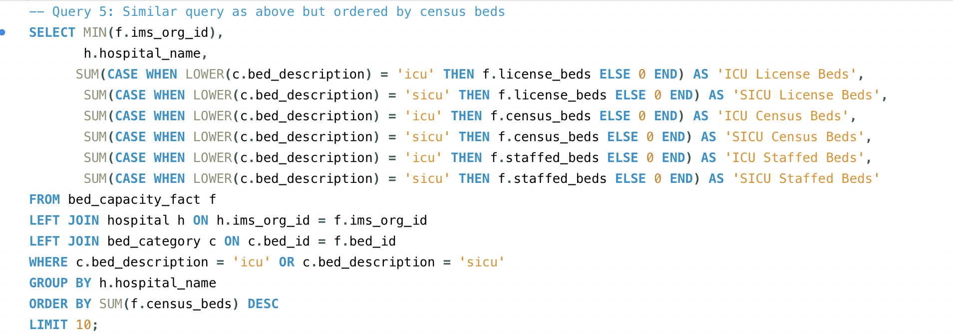

Description:

This query is similar to Query 4 but orders the results by total census beds instead of licensed beds. It aggregates the same data from the bed_capacity_fact, hospital, and bed_category tables.

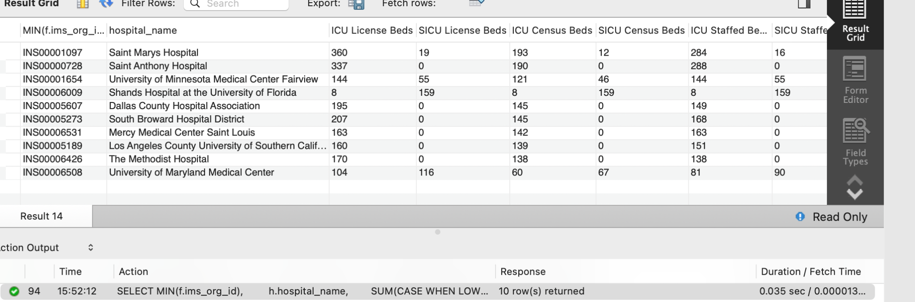

The output displays the top 10 hospitals ranked by census beds available in ICU and SICU. Each row will provide the hospital's name along with the total counts for licensed, census, and staffed beds for both ICU and SICU. This helps identify which hospitals have the highest total bed availability.

6. Query 6: Get ICU and SICU Bed Capacity Ordered by Staffed Beds

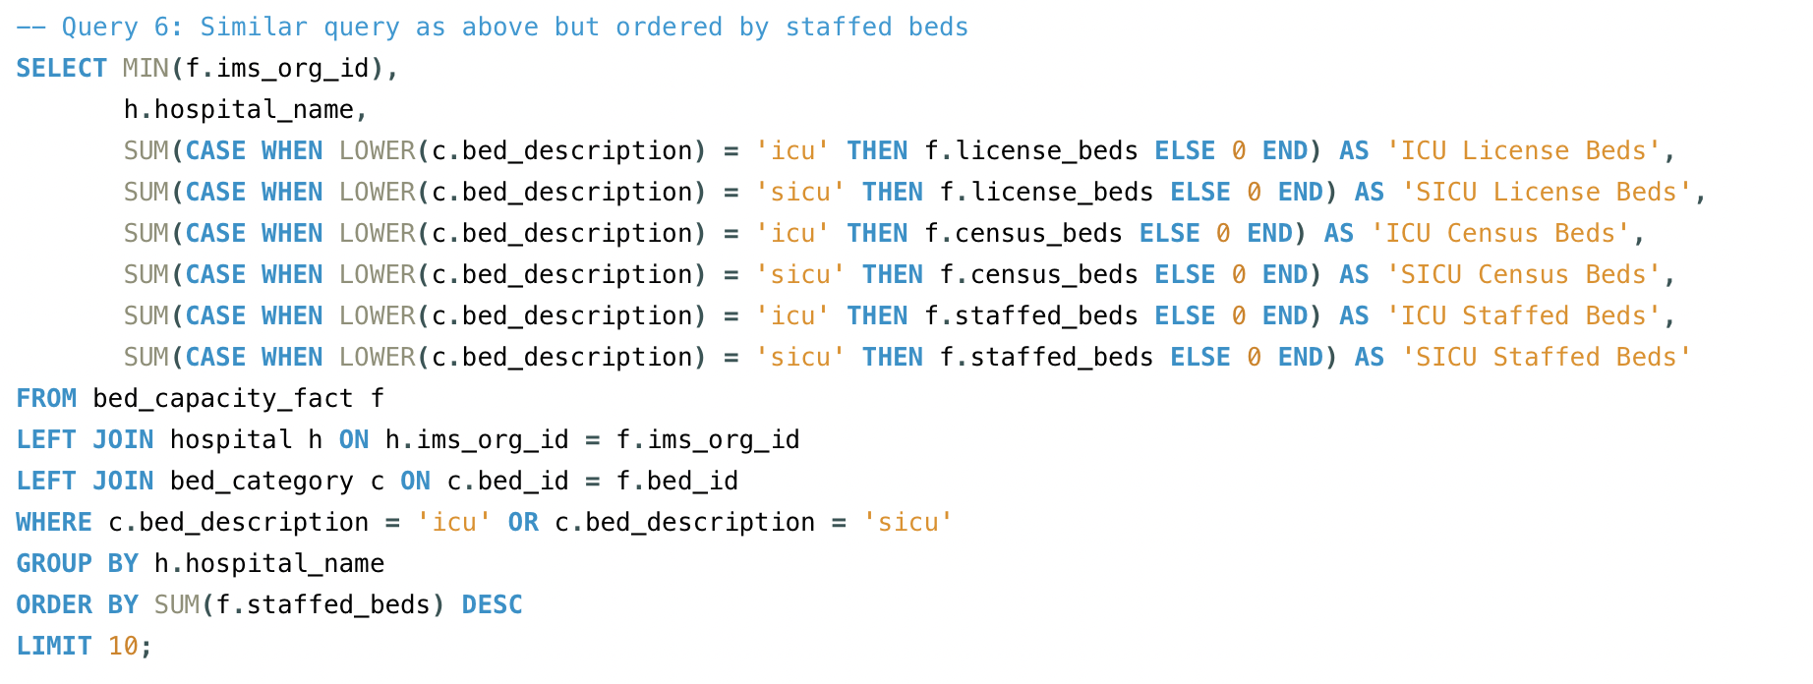

Description:

This query follows the same structure as Queries 4 and 5, but it orders the results by the total number of staffed beds instead. It aggregates ICU and SICU bed counts from the same tables.

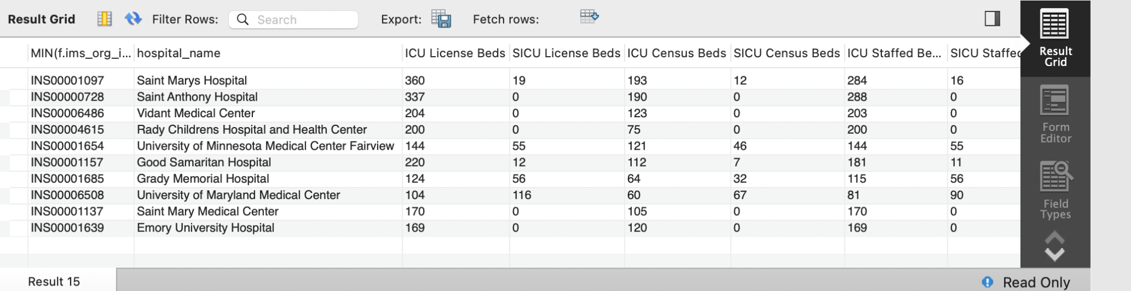

The output presents the top 10 hospitals ranked by the number of staffed beds in ICU and SICU. Similar to the previous queries, each row will display the hospital's name, licensed beds, census beds, and staffed beds for both ICU and SICU. This highlights which hospitals have the most staffing available for critical care beds.

**Client Discussion of Results**

In our analysis of your healthcare network, we have gathered key metrics to support strategic planning and resource management. Here are the insights from the SQL queries performed on your healthcare database:

**1. Total Number of Licensed Beds**

Licensed beds represent the maximum number of beds a hospital can legally operate, an important factor for understanding capacity during emergencies or patient surges.

Key Findings:

Saint Marys Hospital leads with 360 licensed ICU beds and 19 SICU beds, reflecting a strong capacity to manage critical patients.

Saint Anthony Hospital and Phoenix Children's Hospital also have notable licensed bed capacities, indicating their readiness to handle increased patient loads.

Implications:

These figures are crucial for planning patient transfers and determining where to expand capacity to meet demand while staying within state regulations. Knowing which hospitals have the highest licensed capacity enables your network to effectively allocate resources and ensure patient safety during peak times.

2. Total Number of Census Beds

Census beds represent the number of beds currently occupied or available for patient care, providing a real-time view of hospital resource utilisation.

Key Findings:

Saint Mary's Hospital again ranks highest, with 193 ICU and 12 SICU census beds in use, demonstrating efficient use of its licensed resources. This reflects the hospital's ability to maximise its operational capacity while maintaining a focus on patient care.

Implications:

Understanding real-time bed occupancy helps in optimising patient flow and ensuring resources are used effectively across your network. Monitoring census beds is particularly useful during patient surges, allowing for better planning and coordination among hospitals.

3. Total Number of Staffed Beds

Staffed beds indicate the number of beds supported by adequate personnel, which is vital for maintaining patient care.

Key Findings:

Saint Mary's Hospital leads with 284 ICU and 16 SICU staffed beds, demonstrating both physical infrastructure and sufficient staffing levels to support patient care adequately.

Implications:

Monitoring staffed beds ensures that hospitals can manage patient volumes without straining human resources, guiding staffing and resource distribution. This metric is crucial for maintaining high standards of care, especially during critical situations.

Key Takeaways for Your Network

Consistent Leadership: Saint Mary's Hospital excels across licensed, census, and staffed beds, positioning it as a key facility in your network. Its high capacity and effective utilisation make it an essential resource for critical care.

Strong Competitors: Saint Anthony Hospital and Phoenix Children's Hospital also perform well, particularly in licensed and census beds. However, variations in staffing levels should be monitored to ensure all hospitals can adequately handle patient needs.

Informed Decisions: These metrics allow for data-driven decisions on resource allocation, patient transfers, and future expansions. Understanding each hospital's capabilities will enable your network to respond efficiently to patient demands and operational challenges.

Conclusion

In conclusion, our comprehensive analysis of the healthcare network’s bed capacity has provided critical insights into the operational capabilities of hospitals within the system. By examining key metrics—licensed beds, census beds, and staffed beds—we have highlighted the strengths and areas for improvement across facilities.

Saint Mary's Hospital emerges as a standout facility with significant licensed, census, and staffed bed capacities, establishing it as a cornerstone of critical care within the network. Meanwhile, Saint Anthony Hospital and Phoenix Children's Hospital also demonstrate strong performance, particularly in licensed and census beds, though monitoring staffing levels remains essential.

These findings emphasise the importance of data-driven decision-making in healthcare resource management. By understanding the bed capacity landscape, your network can strategically allocate resources, plan for patient transfers, and prepare for future expansions to meet community healthcare needs effectively.

Moving forward, it is vital for the network to continuously monitor these metrics to ensure optimal utilisation of resources and maintain high standards of patient care. Implementing regular reviews of bed capacities and staffing levels will support the network's goal of providing timely and effective healthcare services, ultimately enhancing the overall patient experience.

We look forward to discussing these insights further and exploring actionable strategies to optimise your healthcare network's performance. Thank you for the opportunity to support your mission in delivering quality care to your community.

References:

W3Schools. (n.d.). SQL INSERT INTO SELECT statement. W3Schools. Retrieved October 9, 2024, from <https://www.w3schools.com/sql/sql_insert_into_select.asp>